Tour ID: 214155  
Tour Name: The Northern Lights of Hidden Iceland - 6 days

Tour destinations: ['Reykjavik', 'Thingvellir National Park', 'Geysir', 'Gullfoss', 'Eyjafjallajokull', 'Vatnajokull National Park', 'Jokulsarlon', 'Hveragerdi', 'Blue Lagoon']

Tour destinations images:

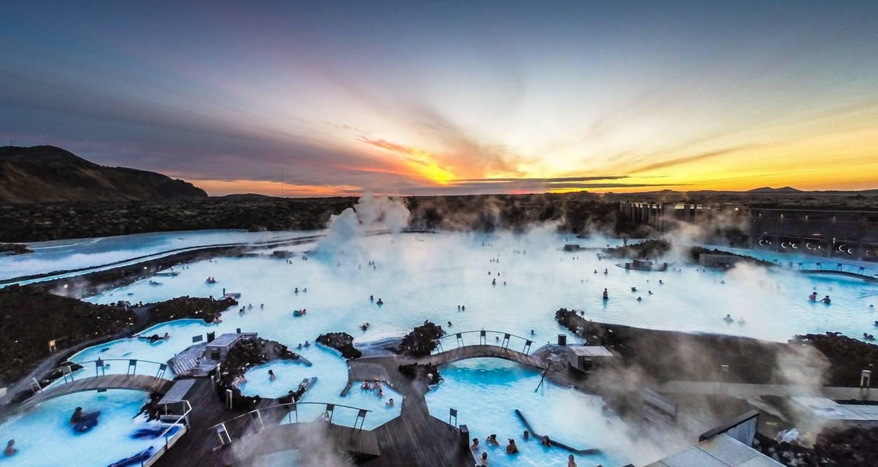

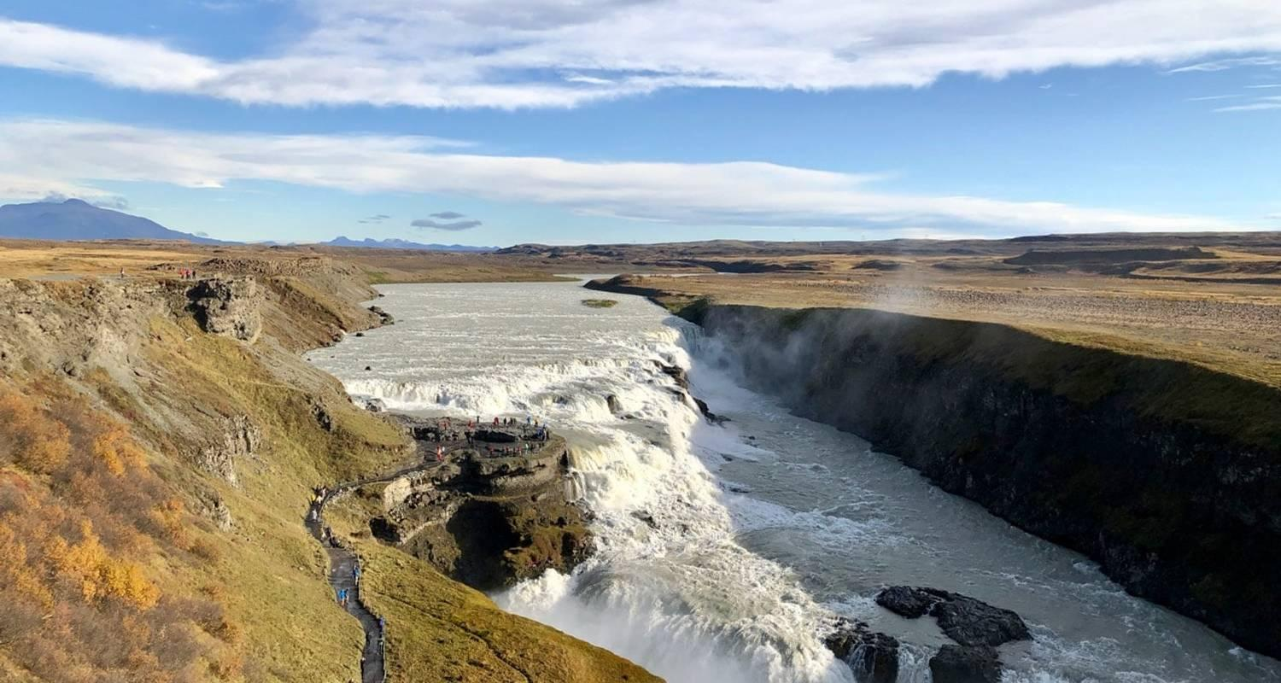

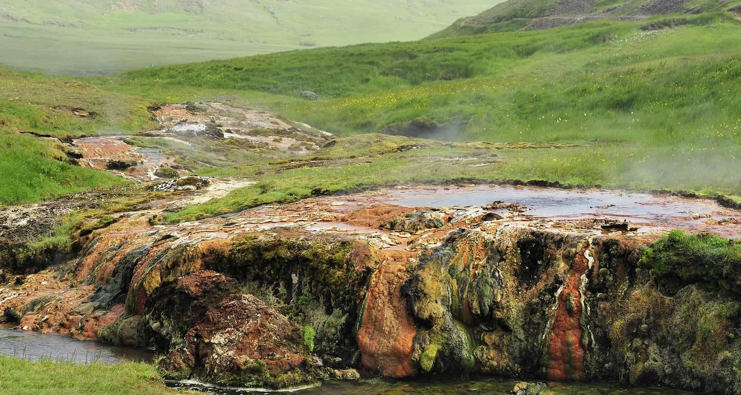

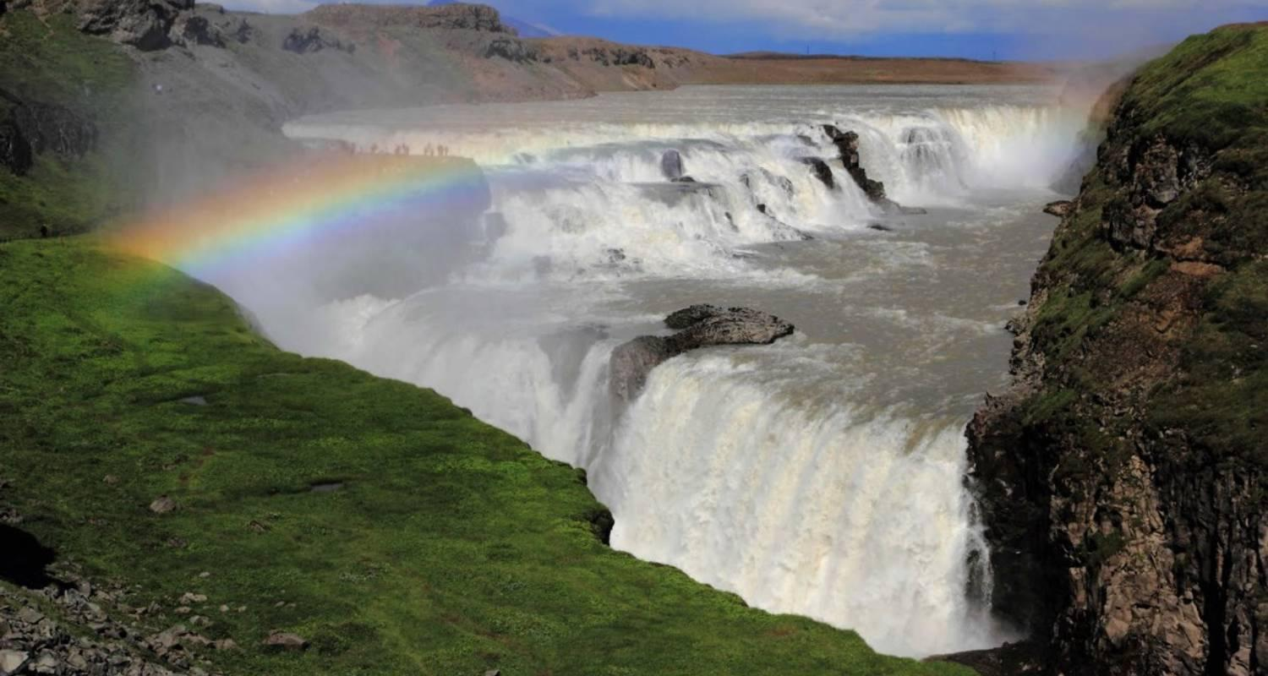

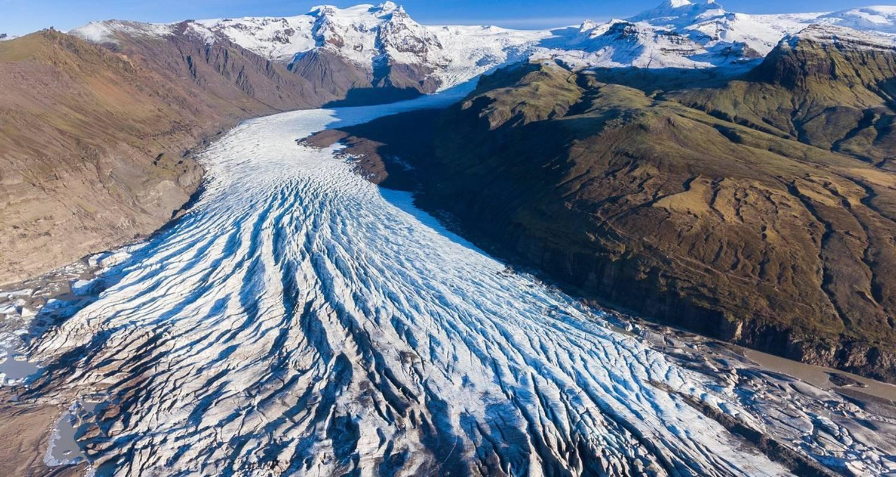

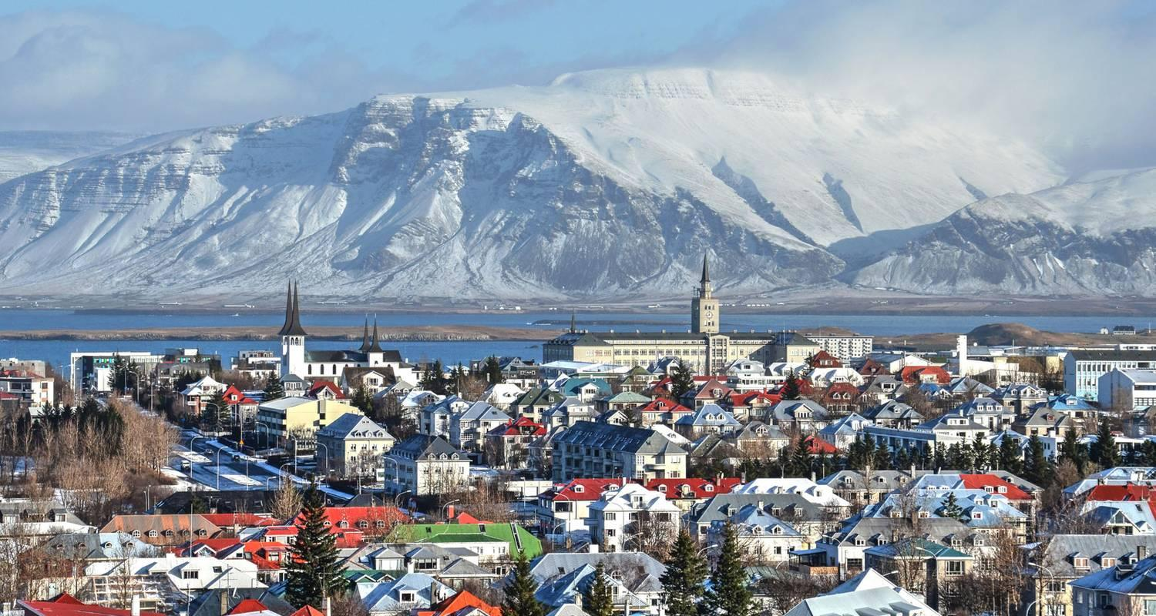

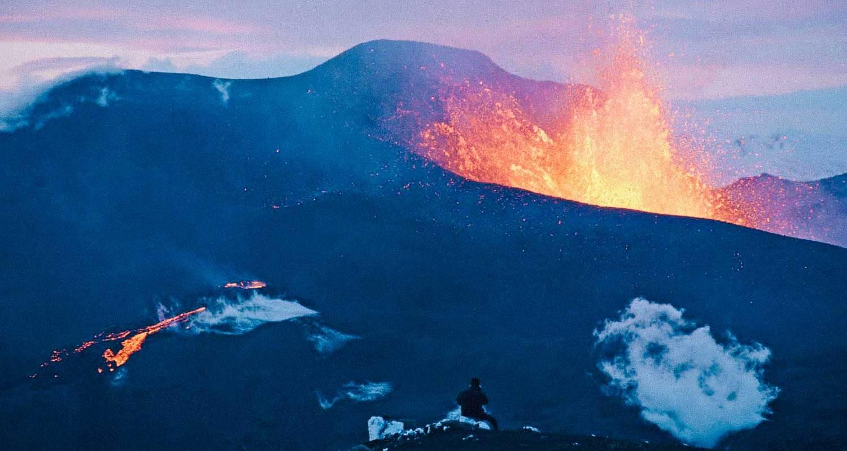

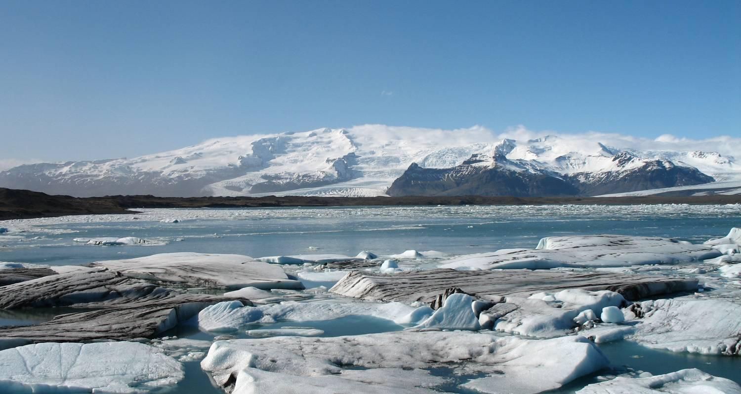

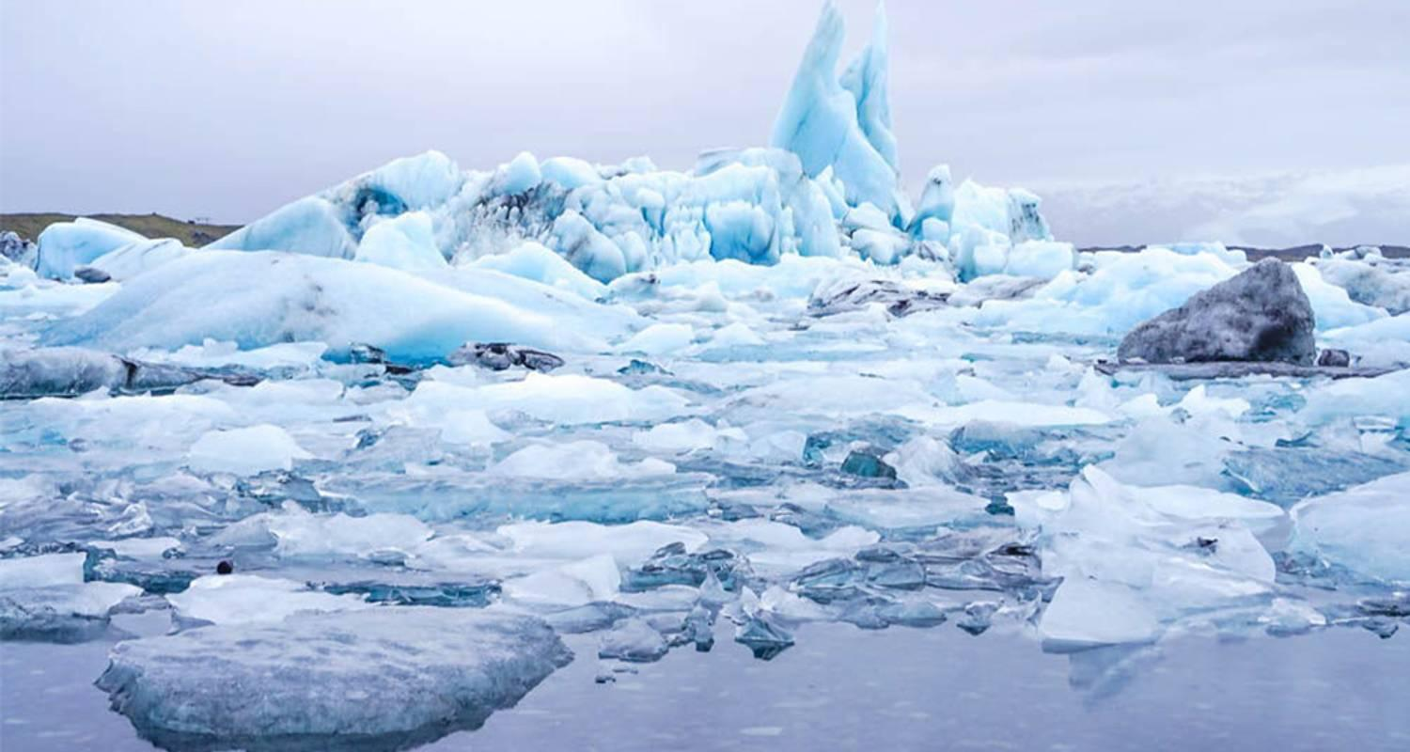

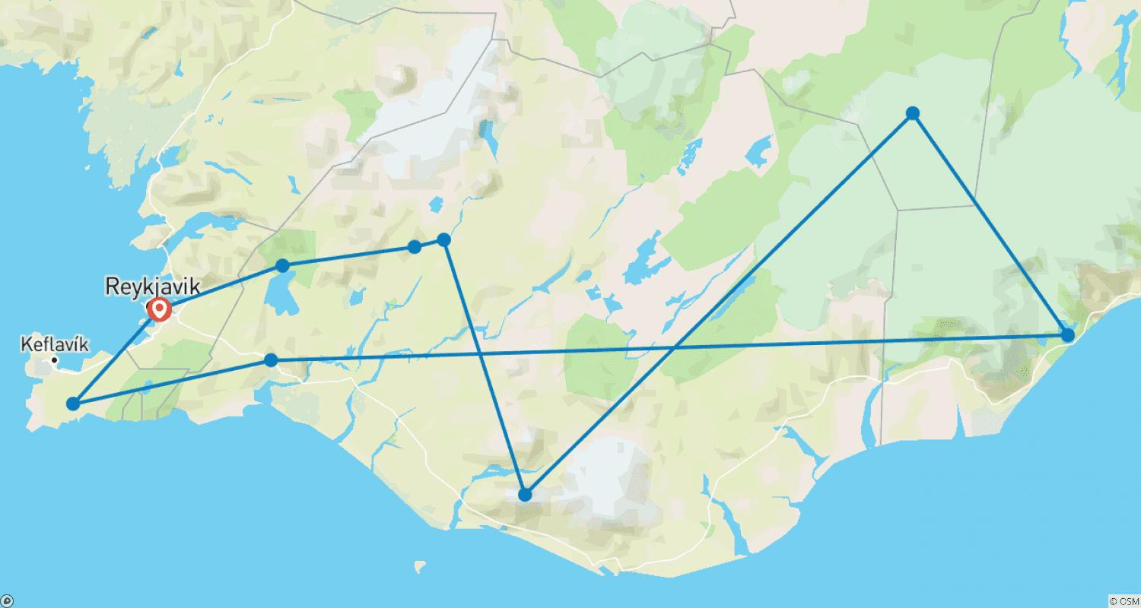

Tour ID: 215063  
Tour Name: 12 Days Iceland Ring Road Tour in a Motorhome

Tour destinations: ['Keflavik', 'Blue Lagoon', 'Kirkjufell Mountain', 'Arnarstapi', 'Hraunfossar', 'Hvitserkur', 'Akureyri', 'Godafoss', 'Myvatn', 'Egilsstadir', 'Djupivogur', 'Hofn', 'Jokulsarlon', 'Skaftafell', 'Vik', 'Skogafoss', 'Hella', 'Gullfoss', 'Geysir', 'Thingvellir National Park', 'Reykjavik']

Tour destinations images:

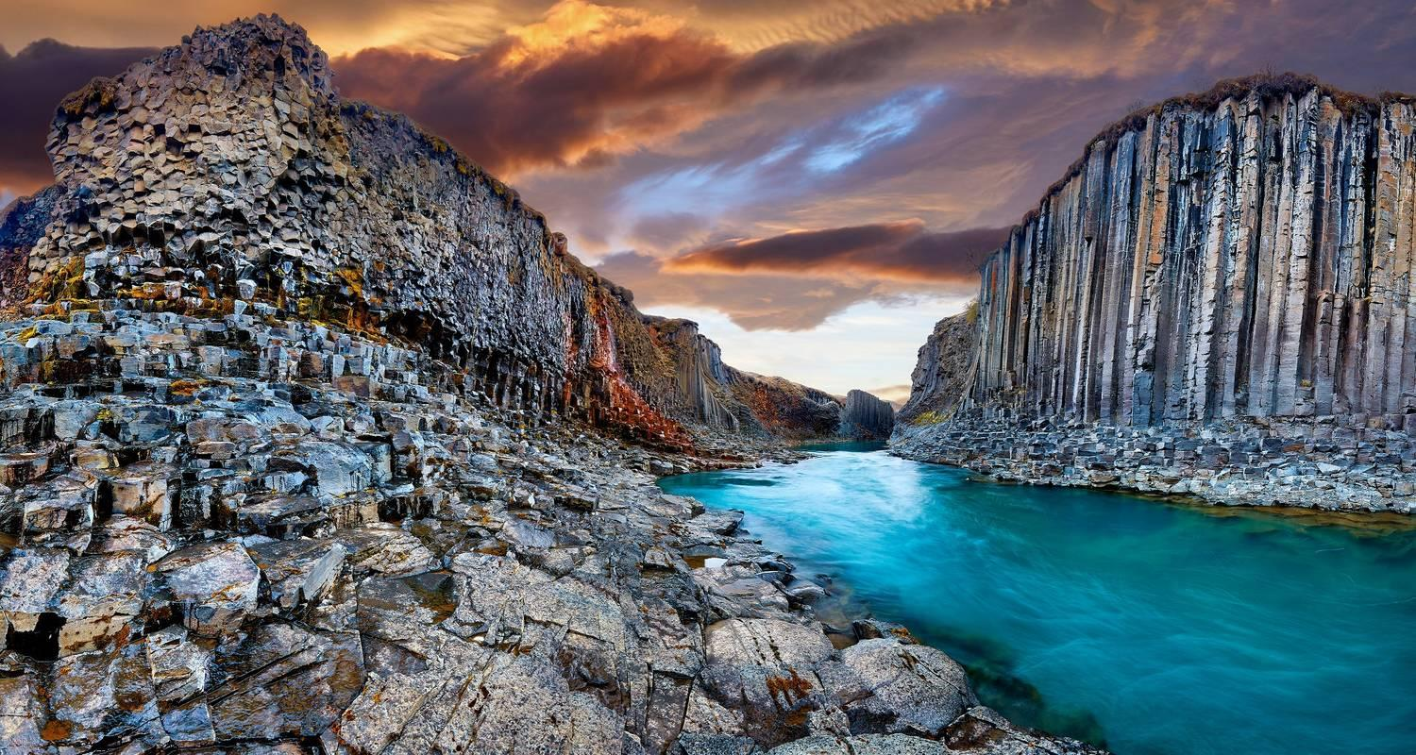

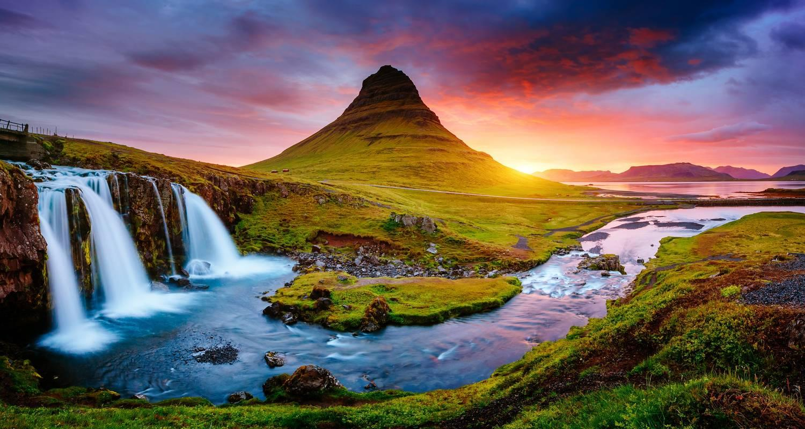

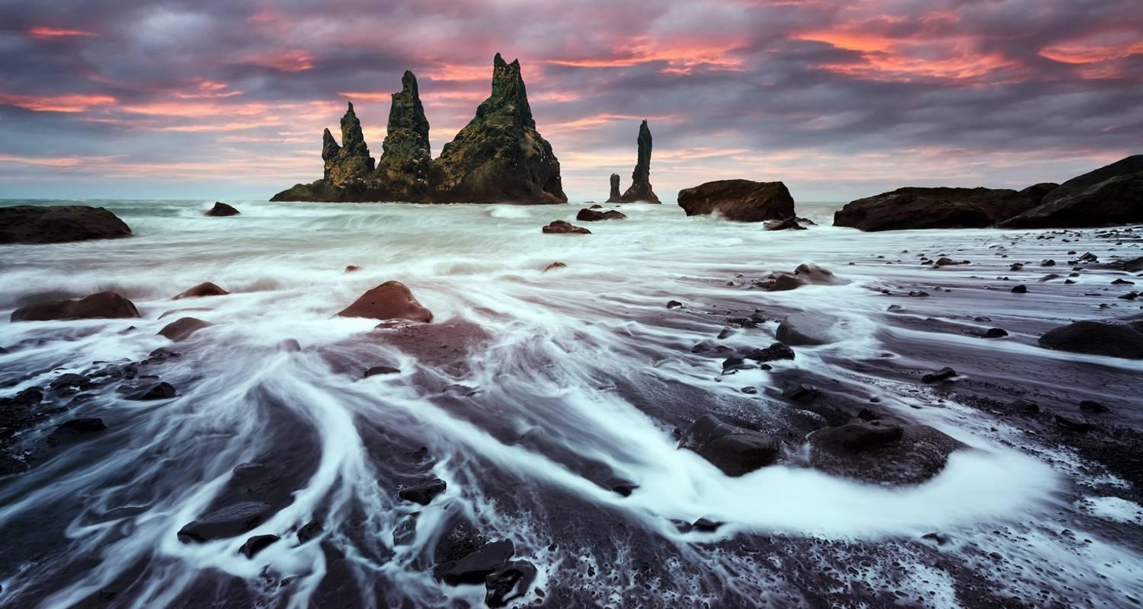

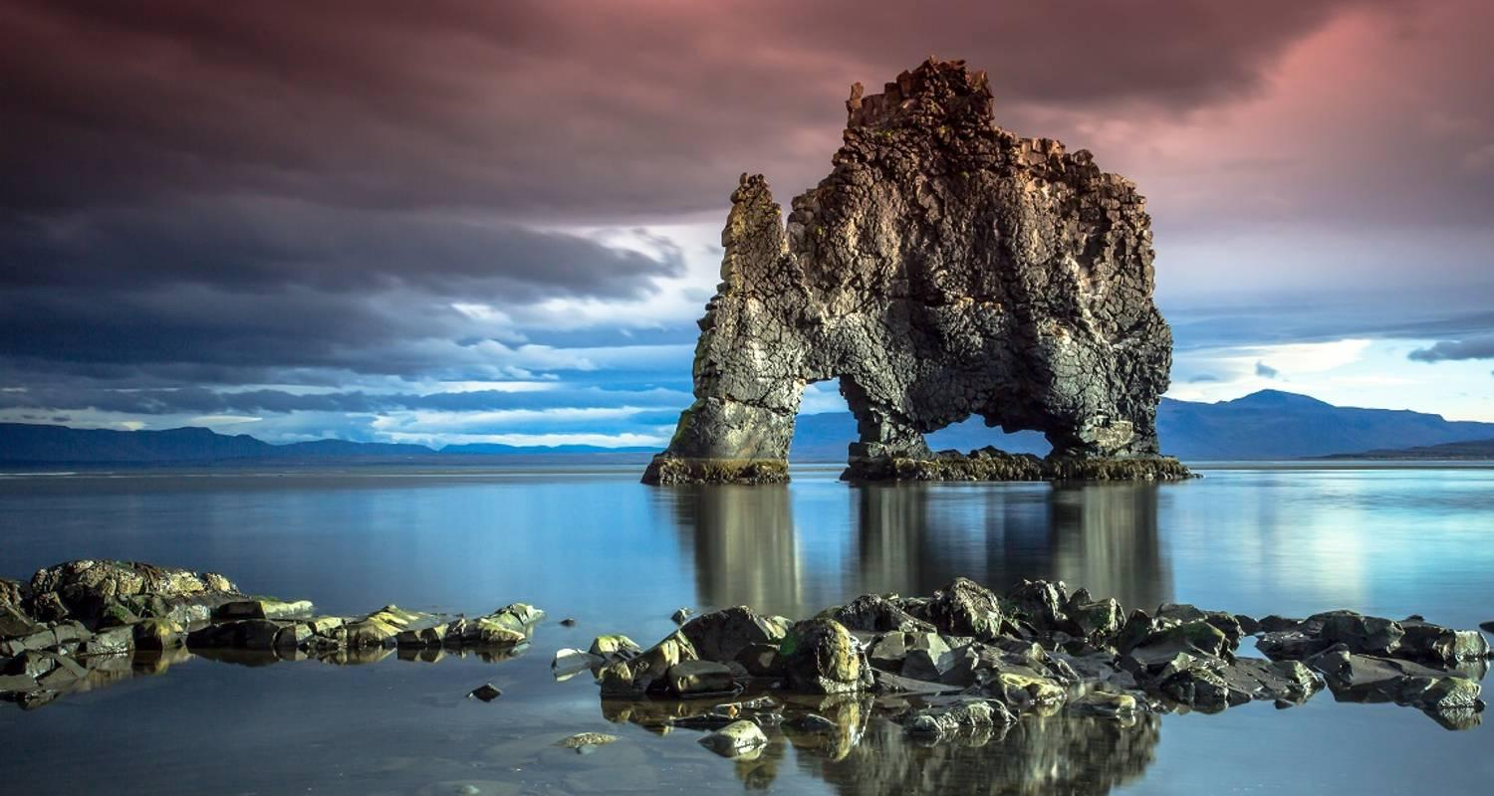

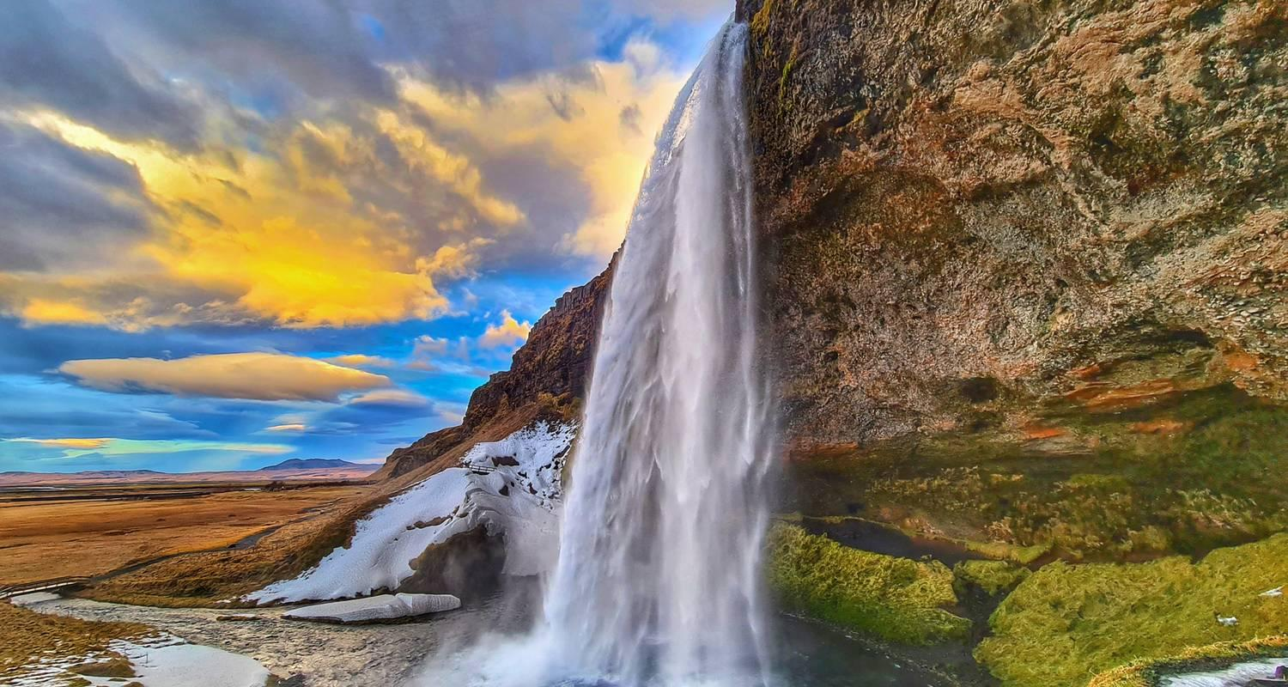

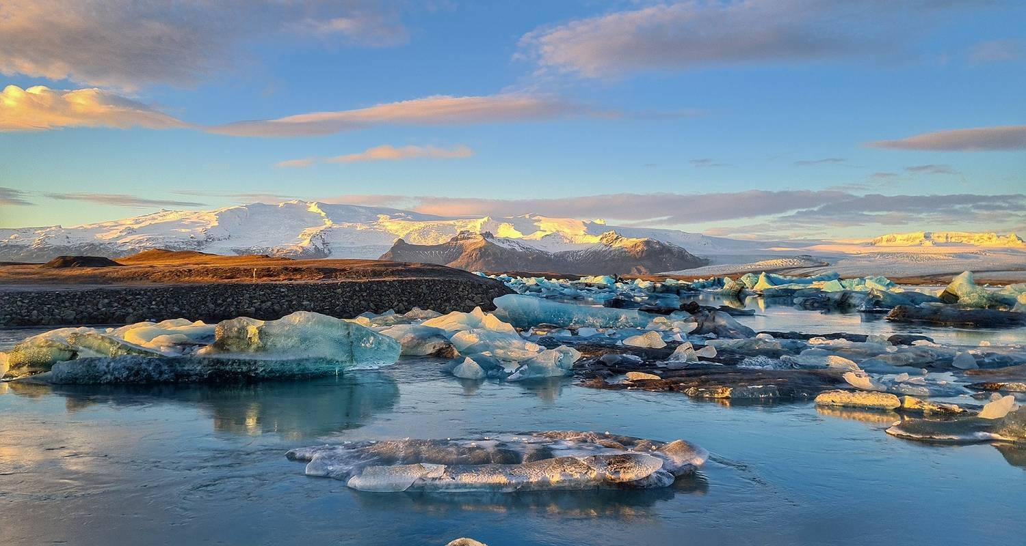

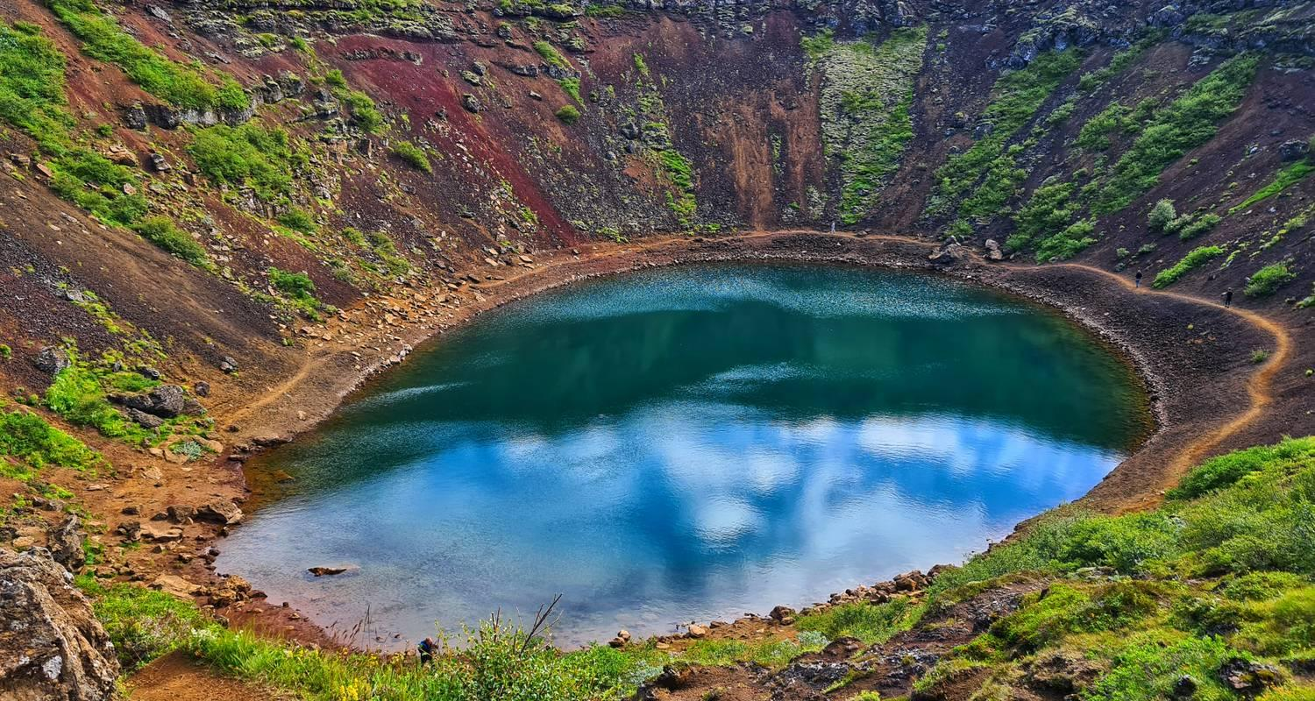

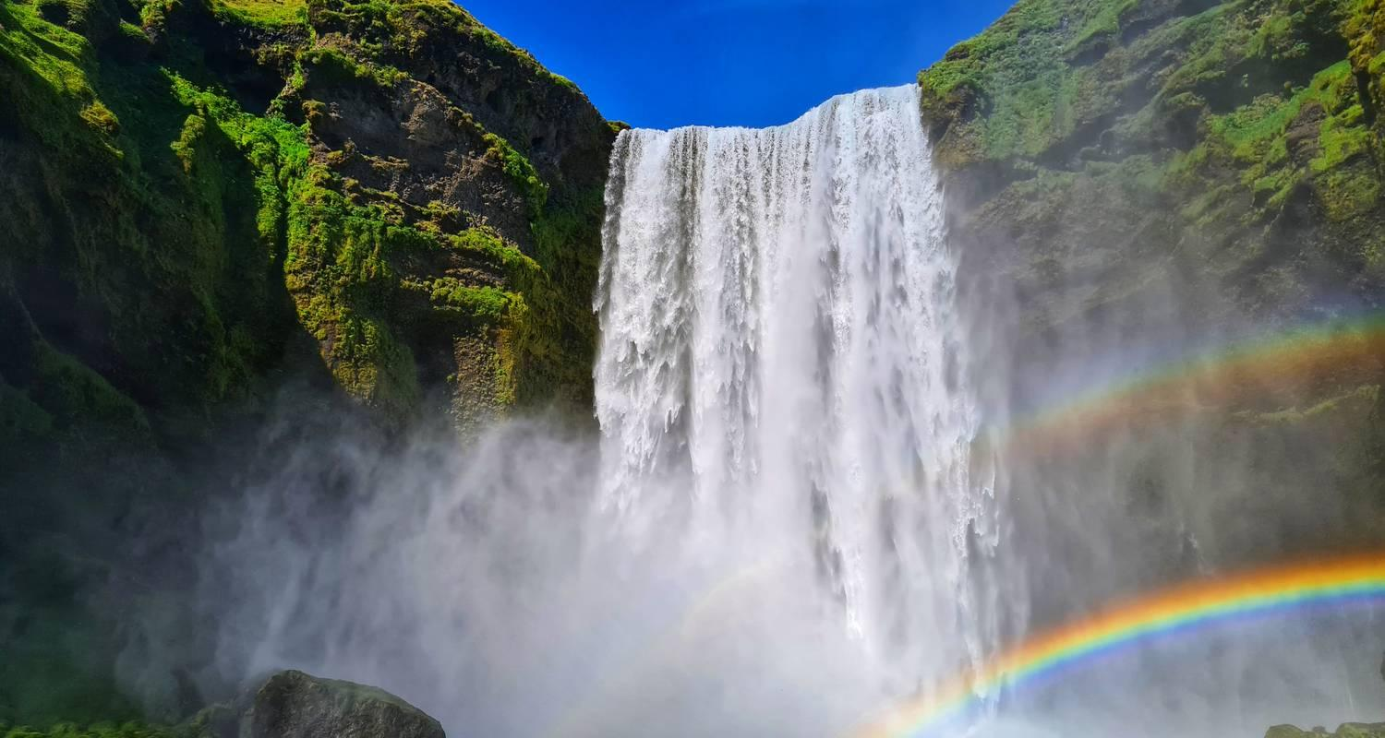

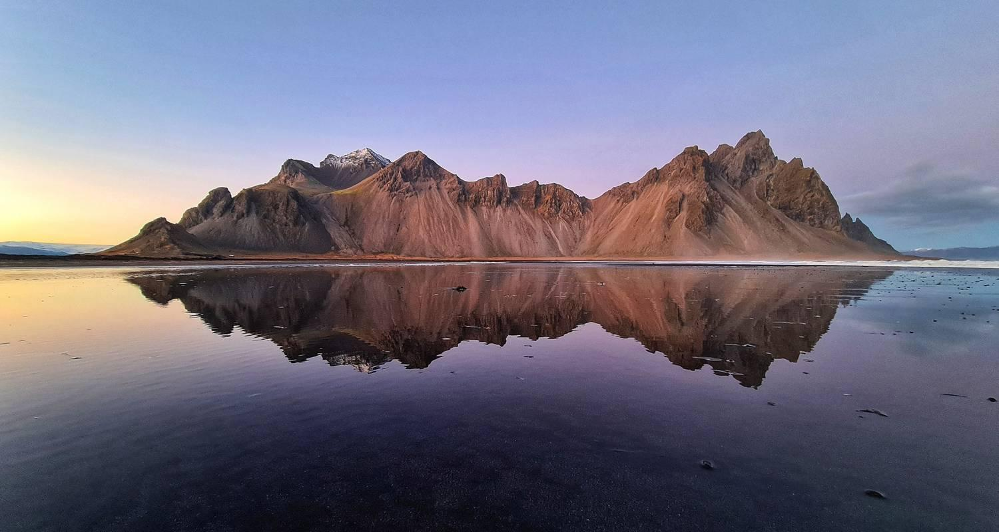

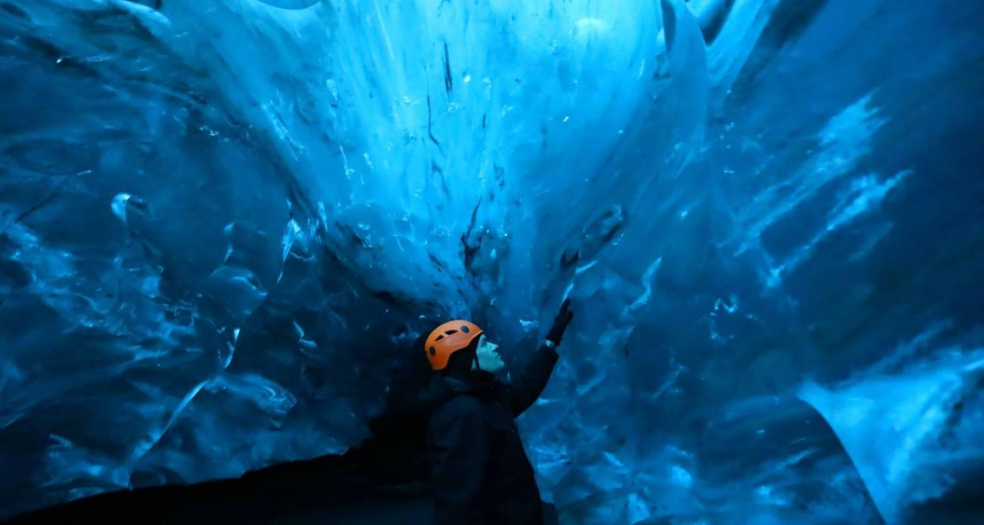

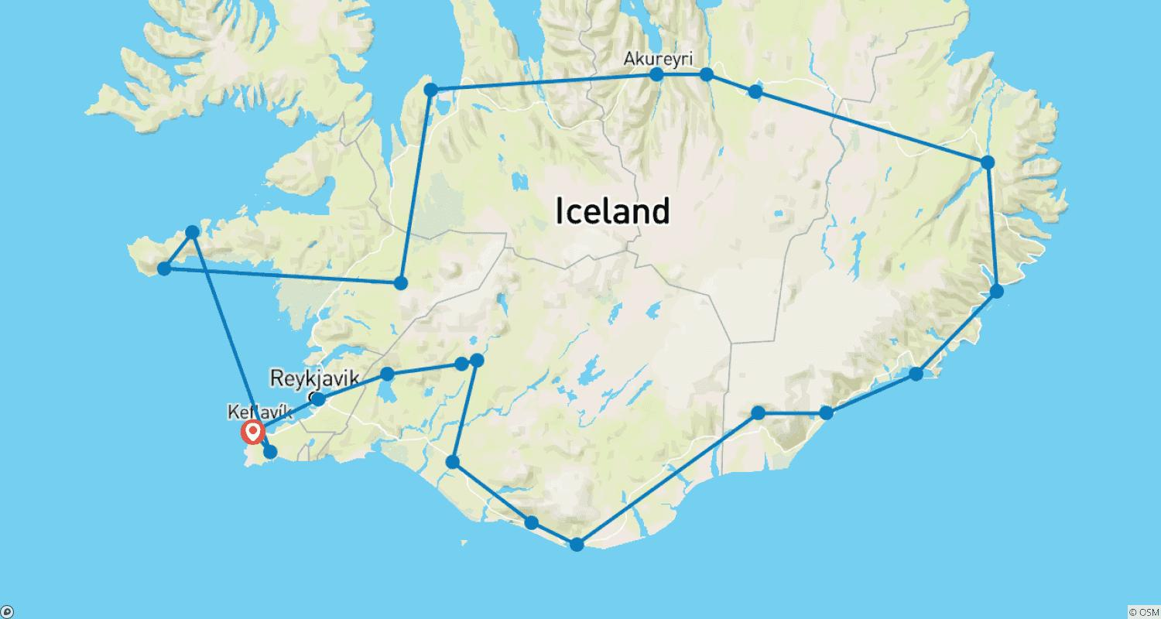

Tour ID: 215309  
Tour Name: Premium Iceland in Winter

Tour destinations: ['Reykjavik', 'Fludir', 'Skaftafell', 'Jokulsarlon', 'Borgarfjörður']

Tour destinations images:

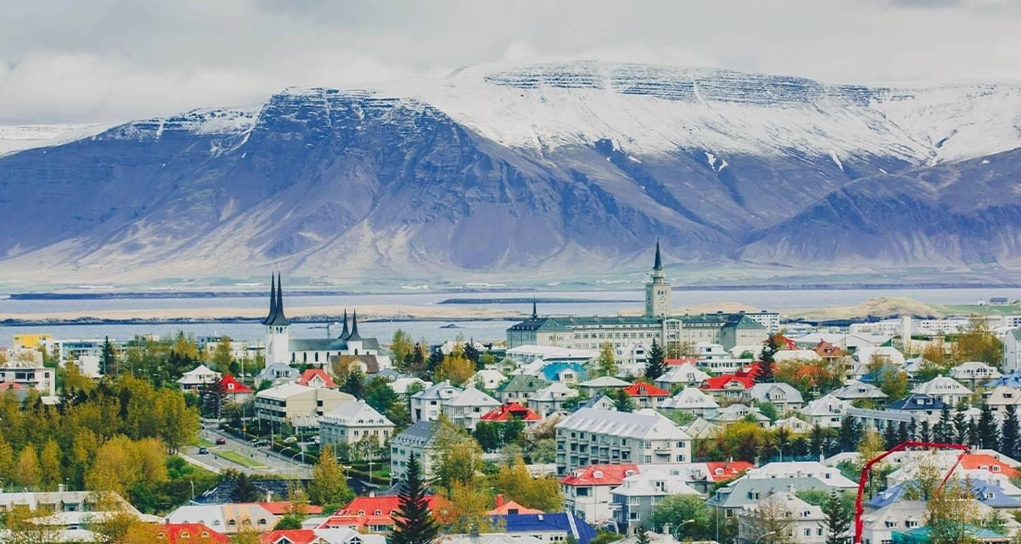

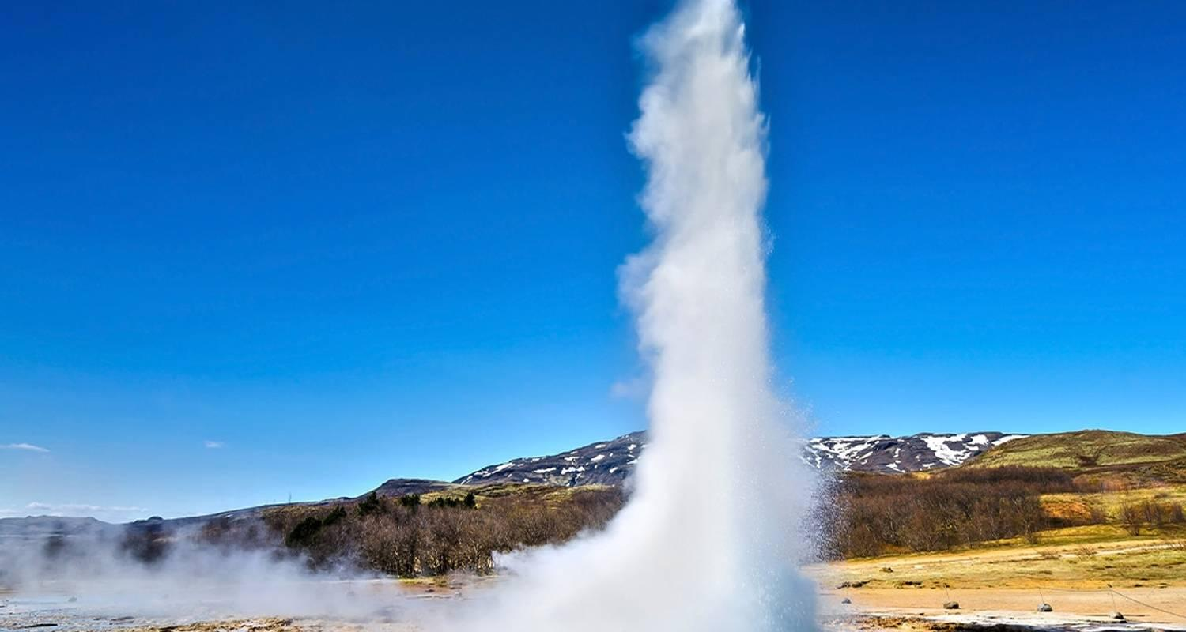

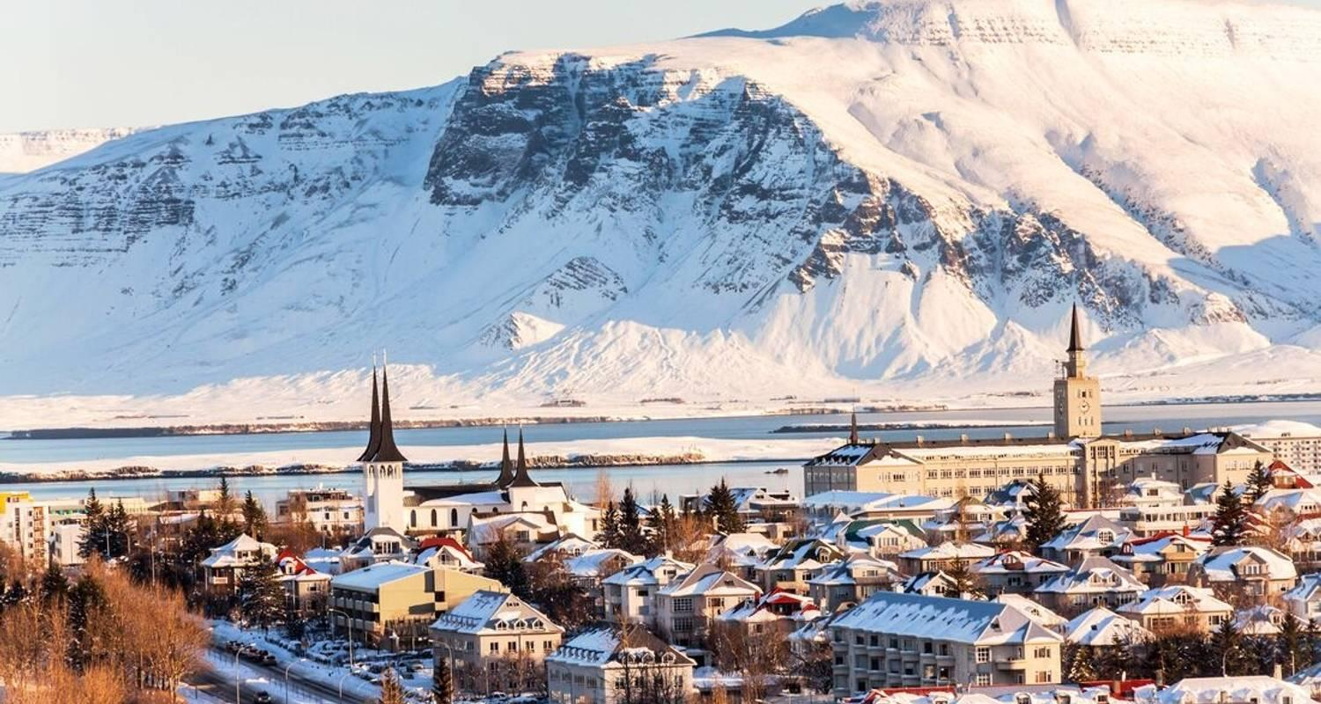

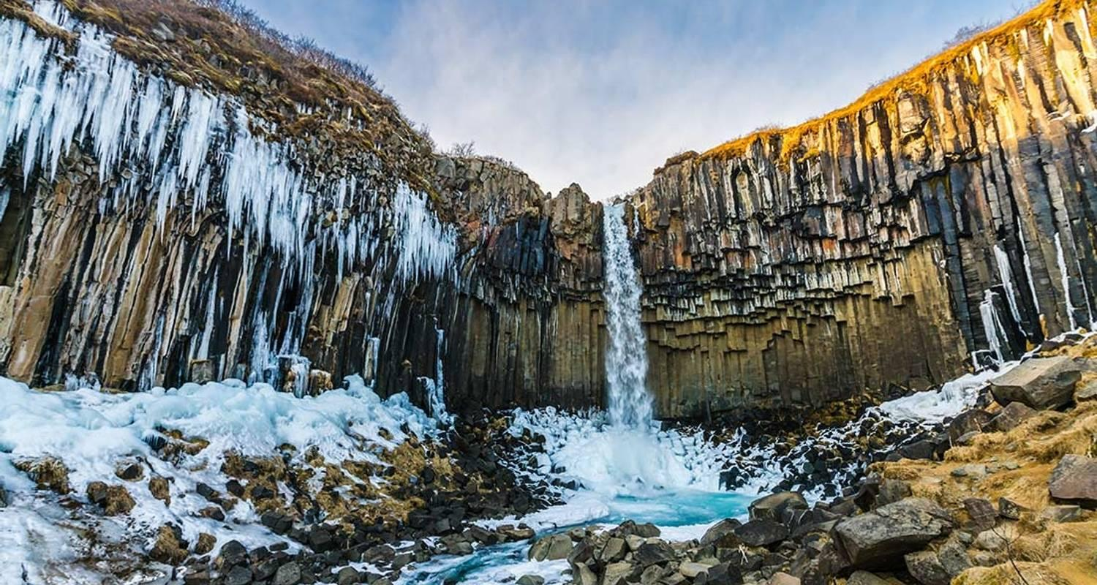

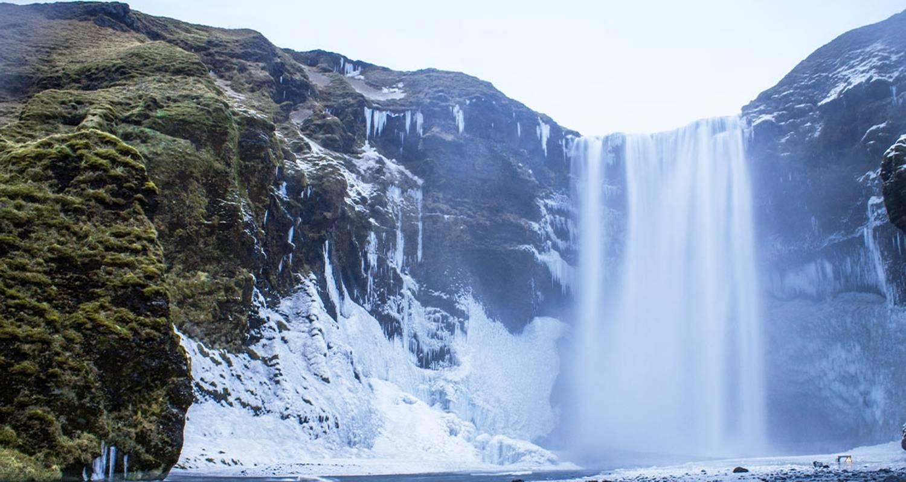

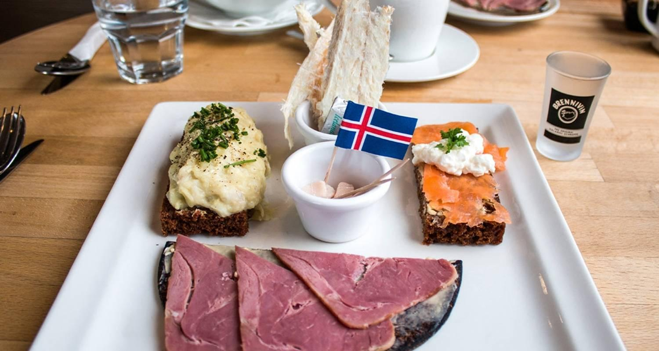

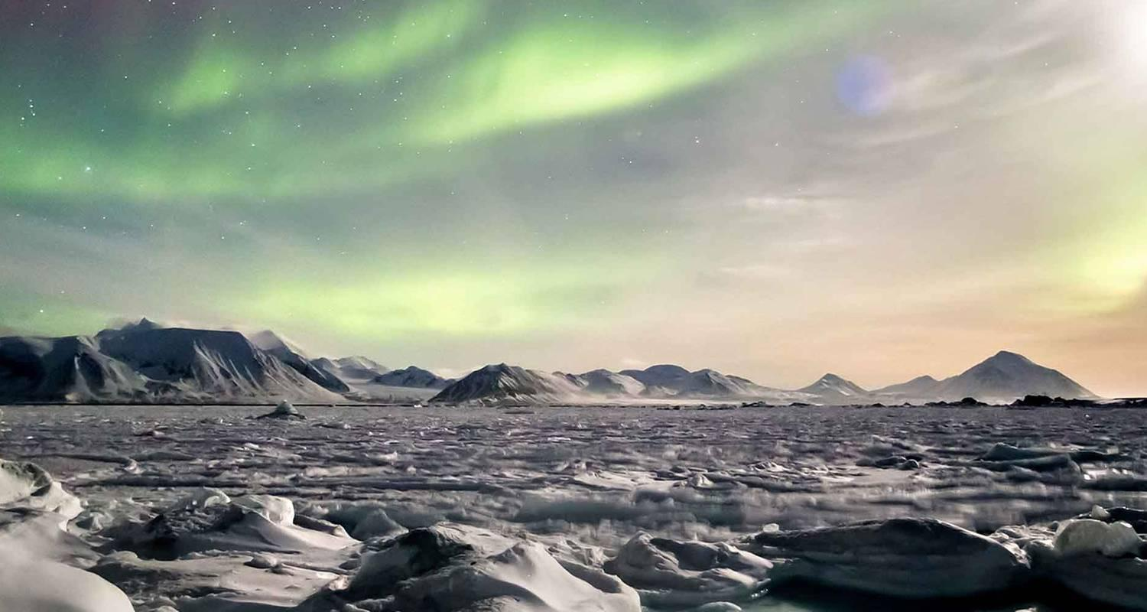

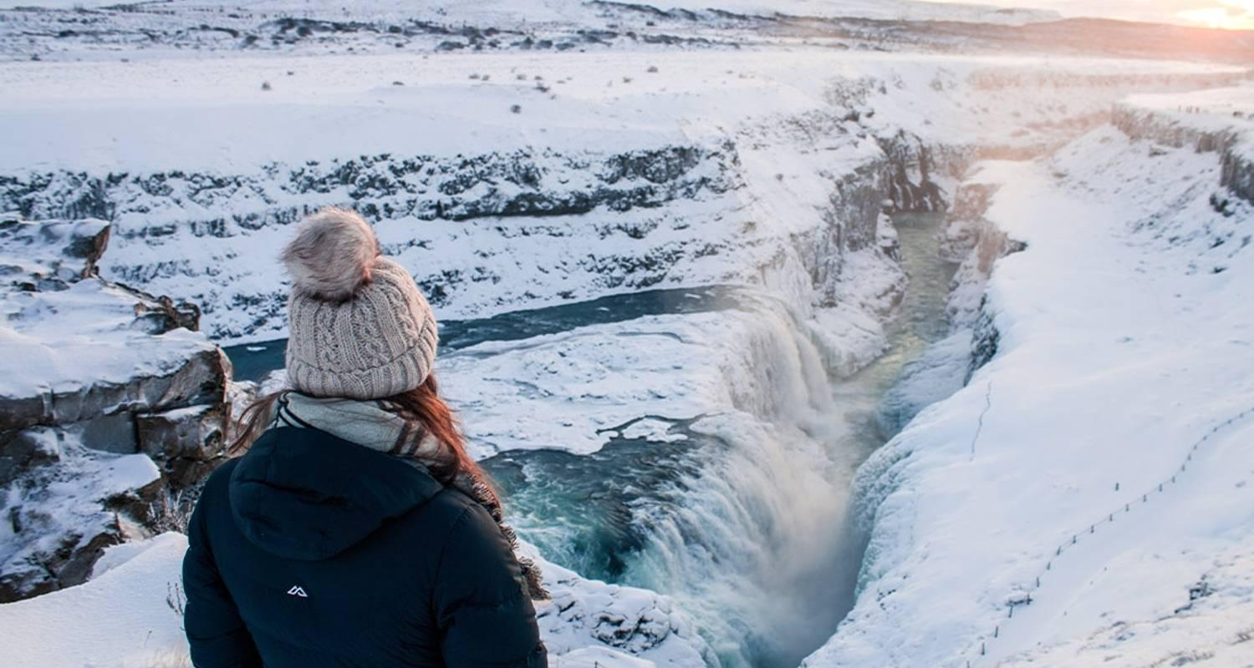

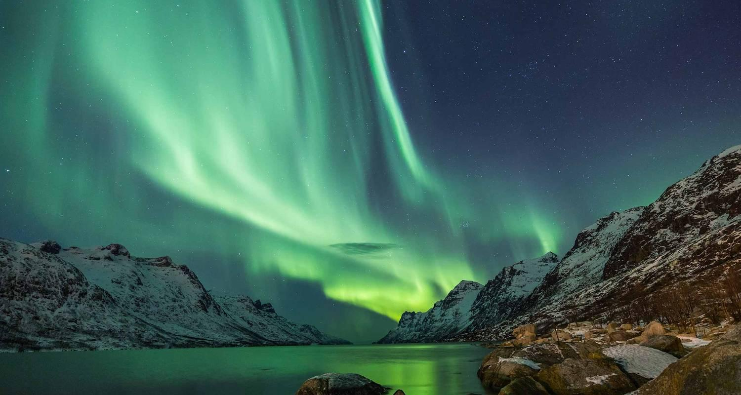

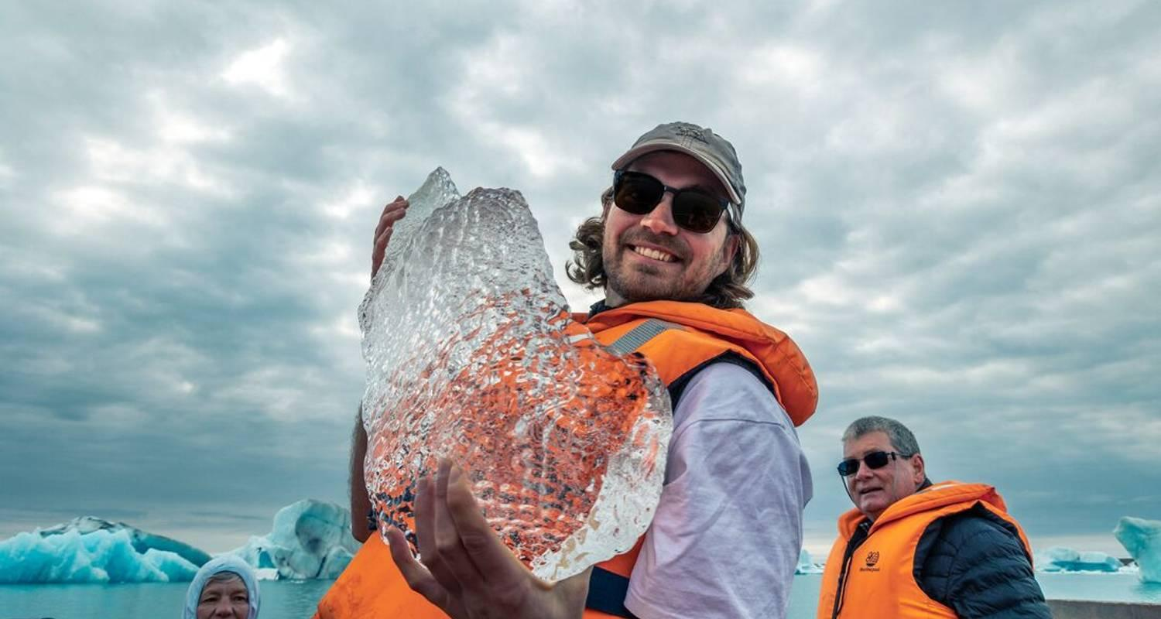

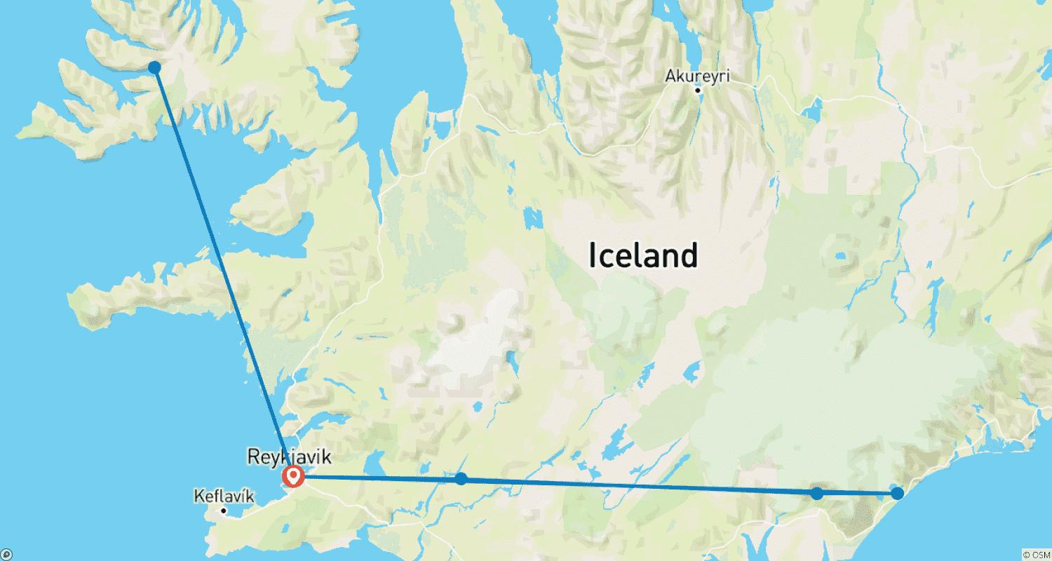

Tour ID: 215626  
Tour Name: 11 Days Self-drive | Ultimate Iceland Ring Road Tour

Tour destinations: ['Keflavik', 'Blue Lagoon', 'Borgarnes', 'Kirkjufell Mountain', 'Arnarstapi', 'Hraunfossar', 'Hvitserkur', 'Siglufjordur', 'Akureyri', 'Godafoss', 'Myvatn', 'Egilsstadir', 'Djupivogur', 'Hofn', 'Jokulsarlon', 'Svartifoss', 'Reynisfjara', 'Skogafoss', 'Seljaland', 'Gullfoss', 'Geysir', 'Thingvellir National Park', 'Reykjavik']

Tour destinations images:



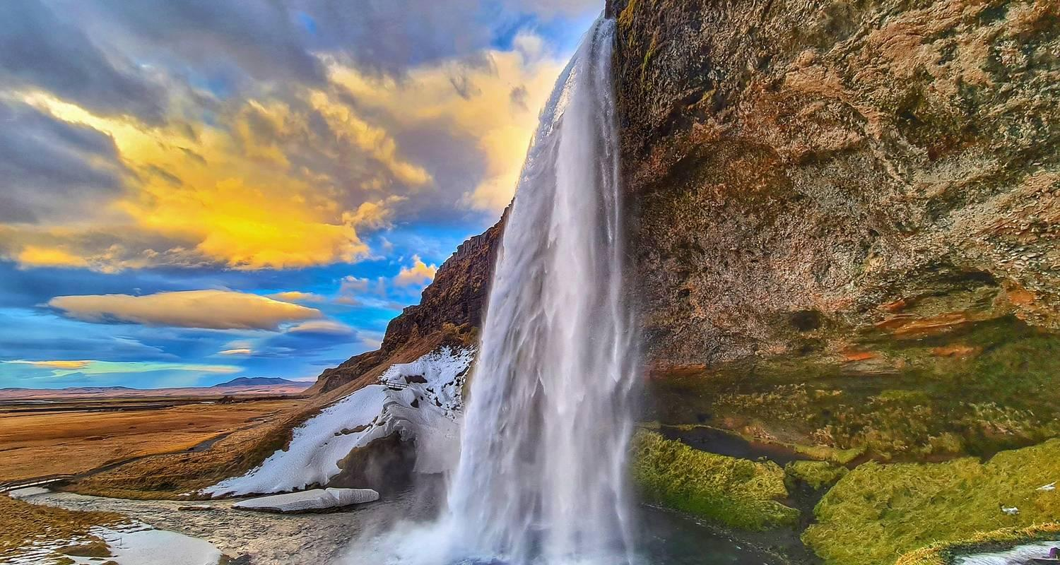



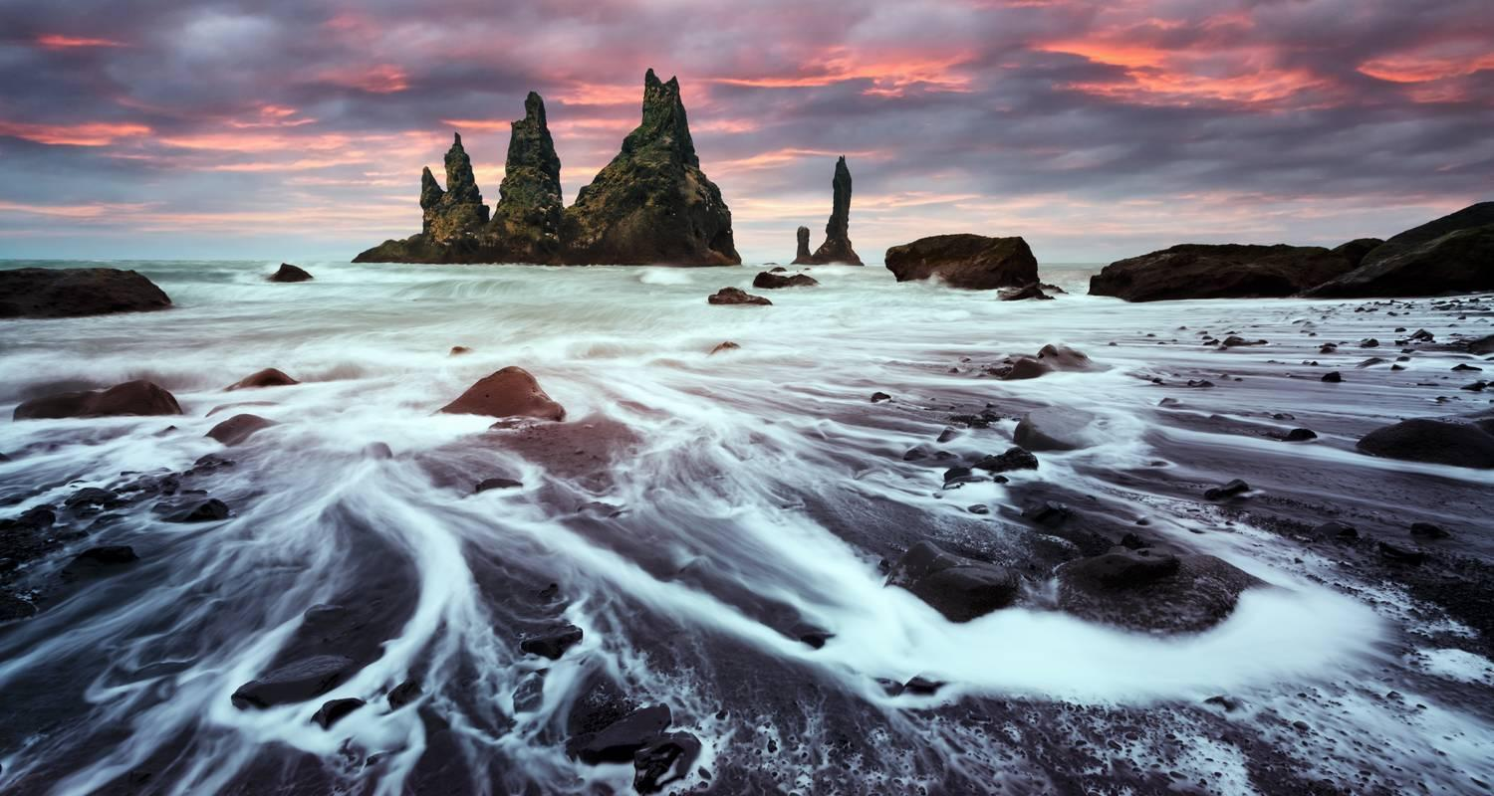



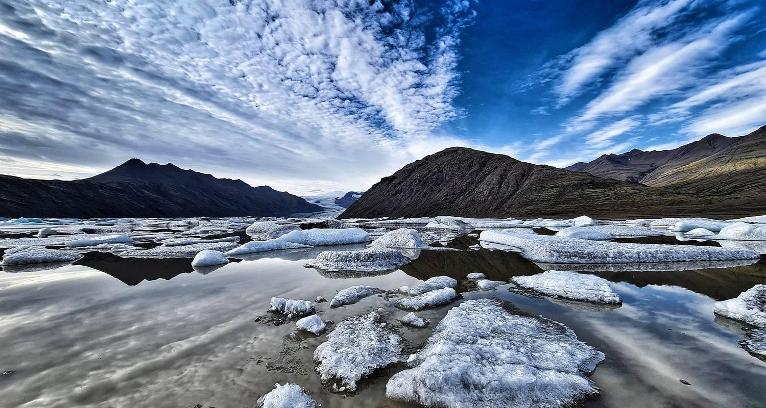





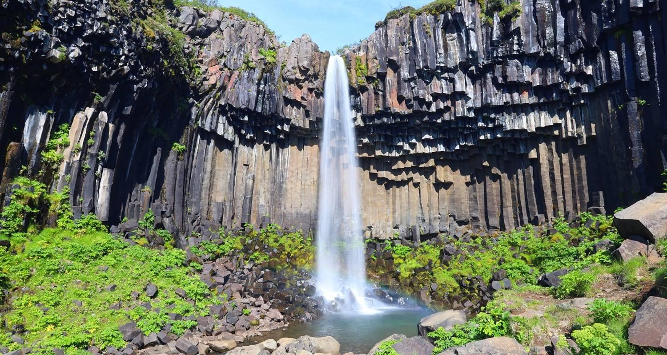



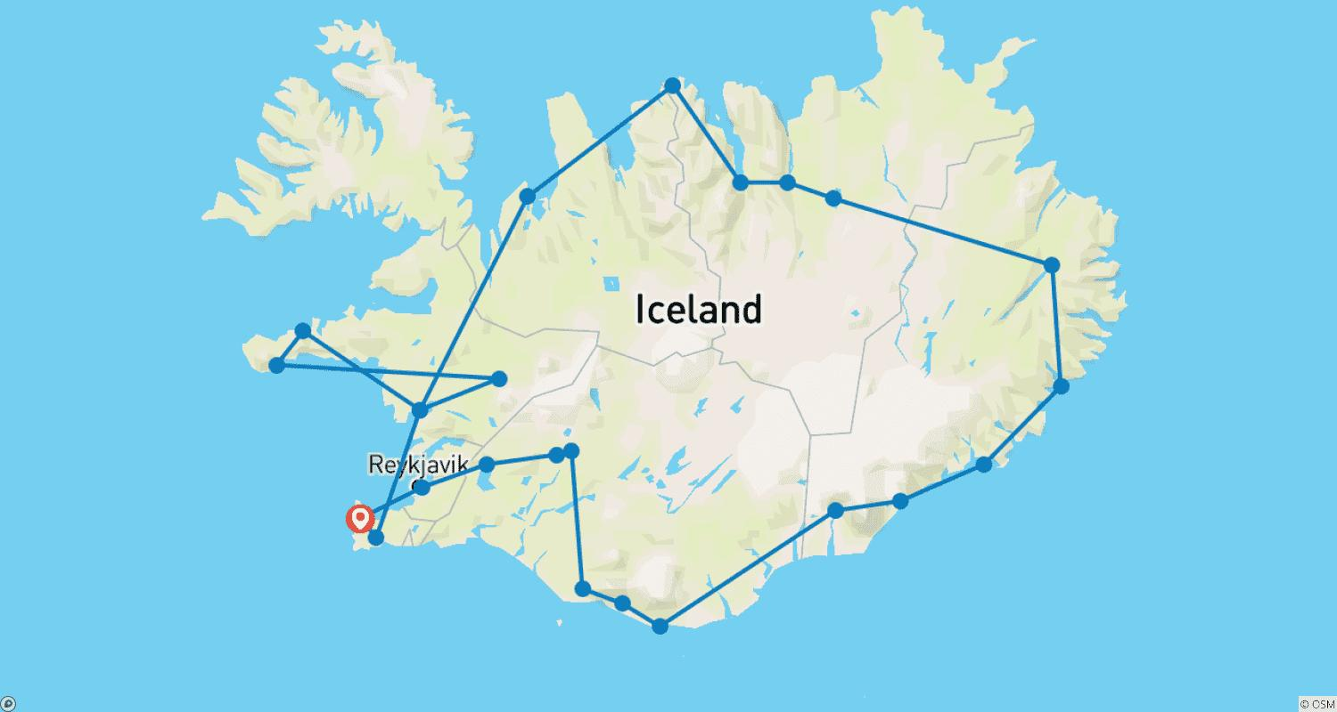

Tour ID: 215809  
Tour Name: 7 Days ICELAND | REYKJAVIK, GOLDEN CIRCLE & SOUTH COAST (Group Tour)

Tour destinations: ['Keflavik', 'Reykjavik', 'Skogafoss', 'Reynisfjara', 'Jokulsarlon', 'Thingvellir National Park', 'Geysir', 'Gullfoss']

Tour destinations images:









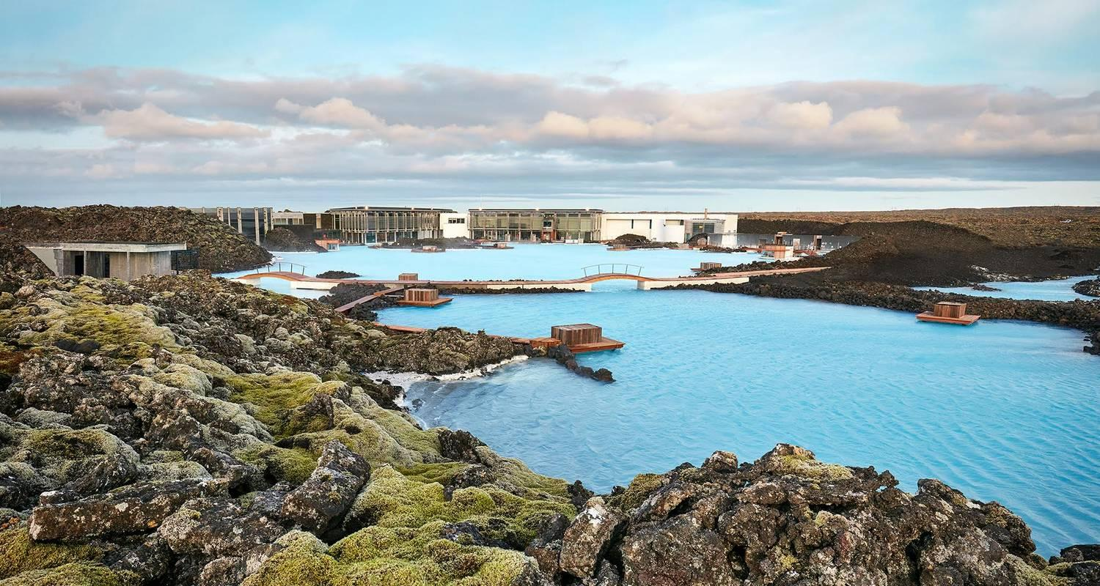

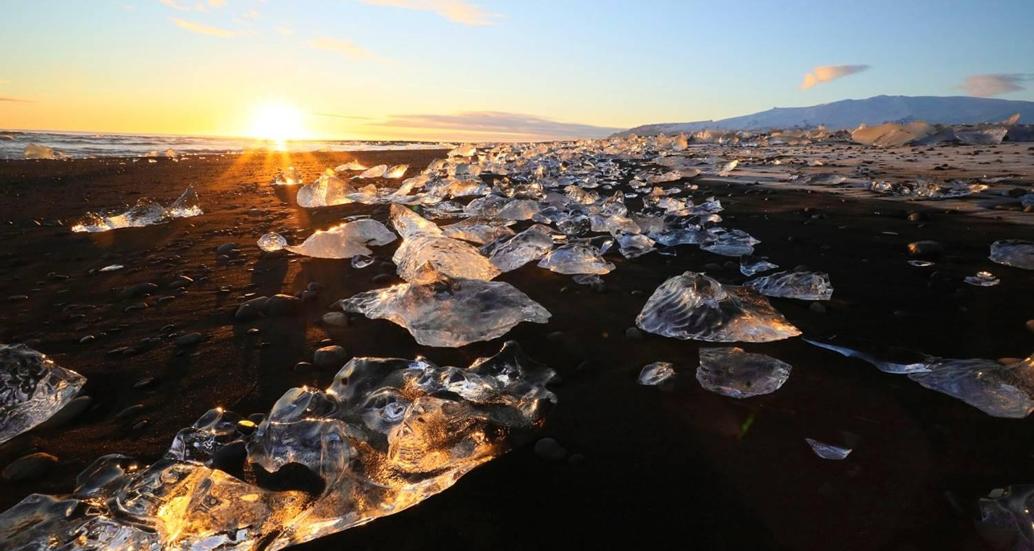

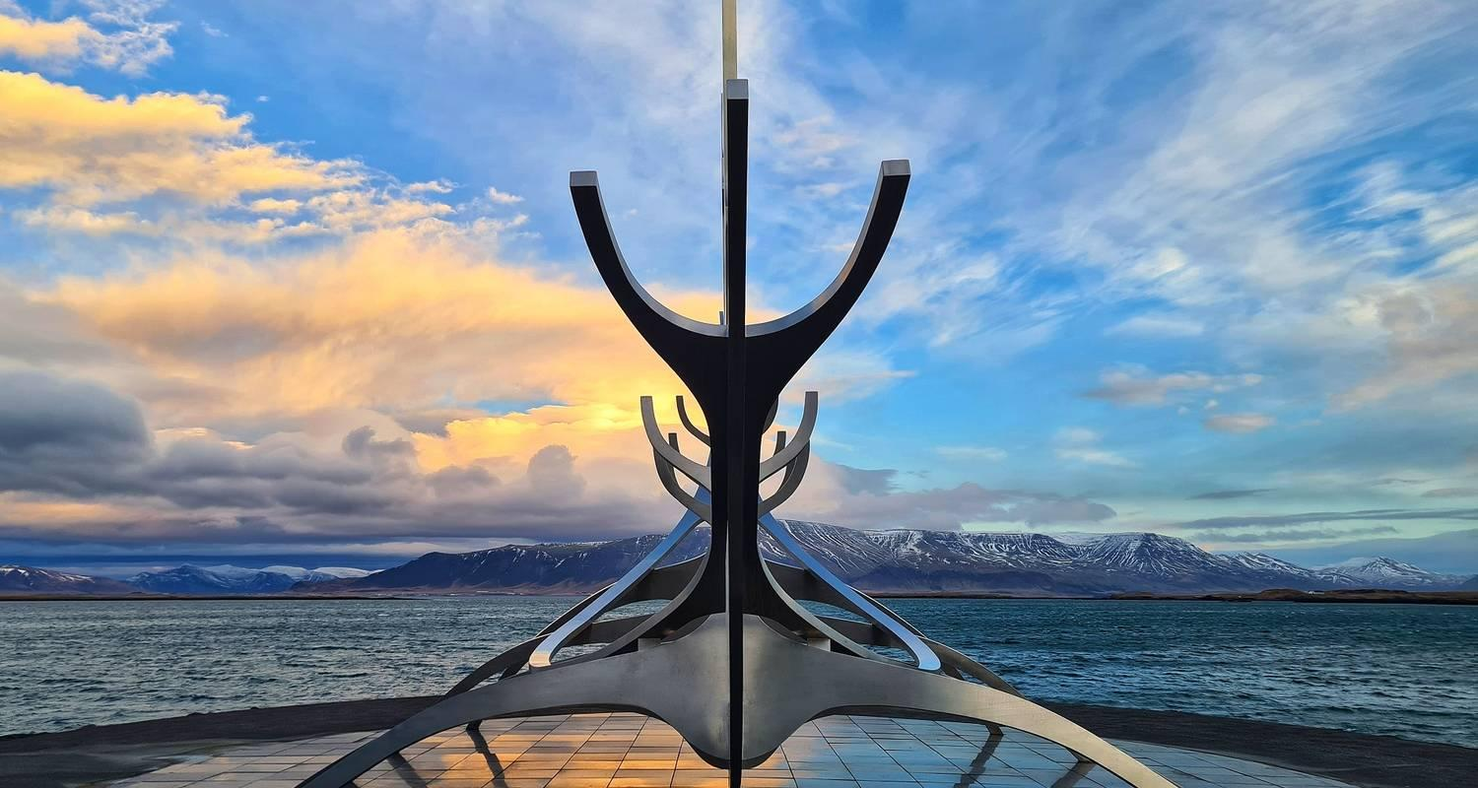





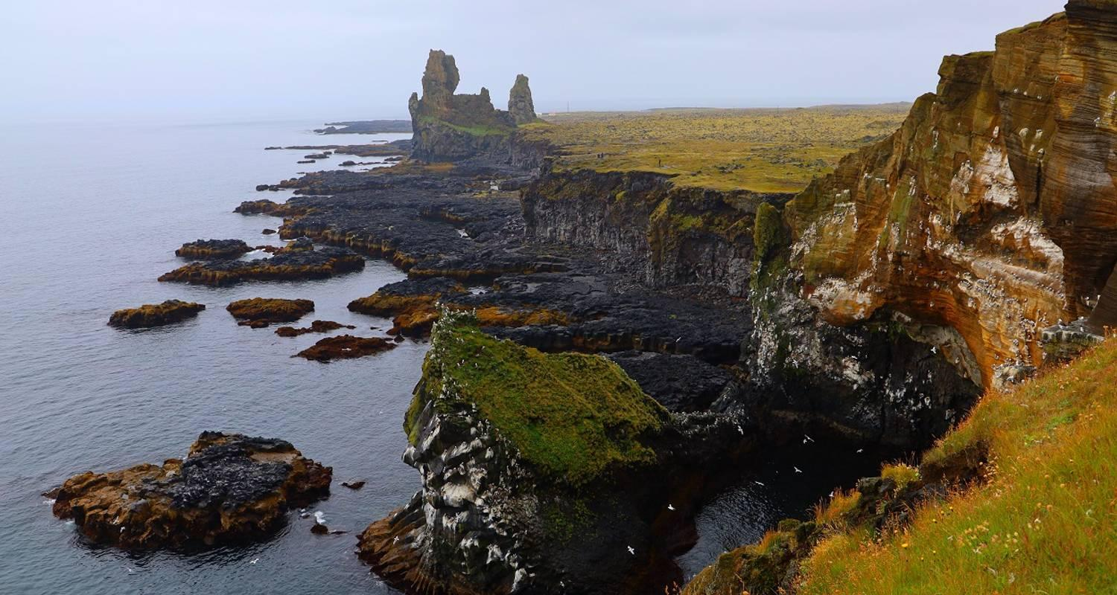

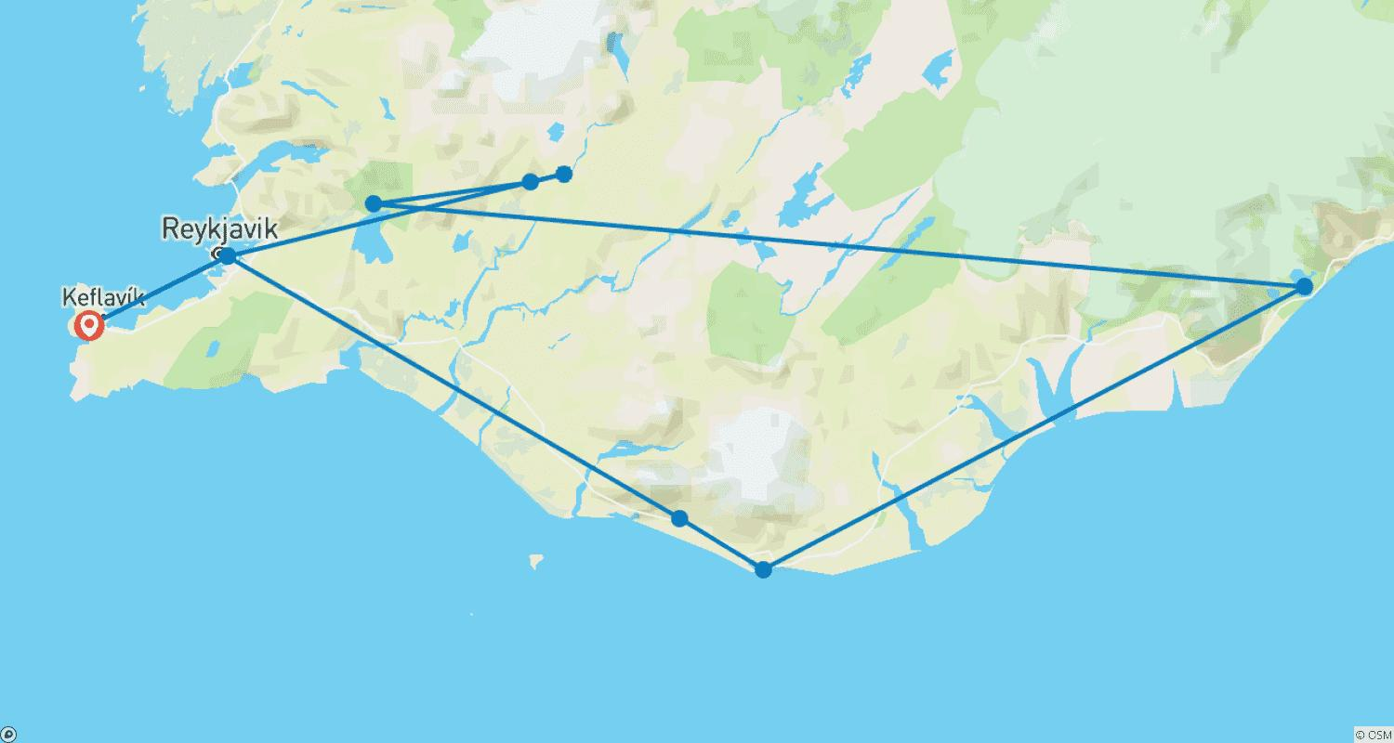

Tour ID: 215813  
Tour Name: 9 Days Self-drive | Ring Road & Golden Circle Complete Iceland Tour

Tour destinations: ['Keflavik', 'Blue Lagoon', 'Borgarnes', 'Hvitserkur', 'Siglufjordur', 'Akureyri', 'Godafoss', 'Myvatn', 'Dettifoss', 'Egilsstadir', 'Djupivogur', 'Hofn', 'Jokulsarlon', 'Reynisfjara', 'Skogafoss', 'Hvolsvollur', 'Gullfoss', 'Geysir', 'Thingvellir National Park', 'Reykjavik']

Tour destinations images:













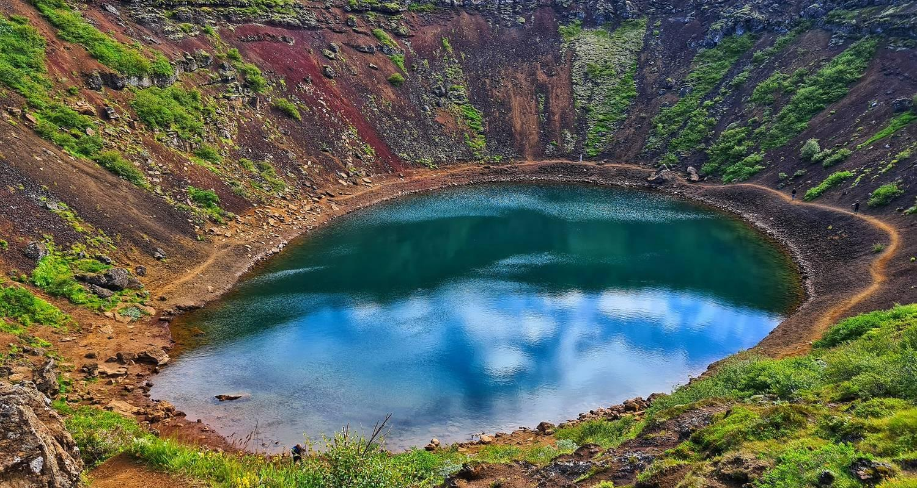

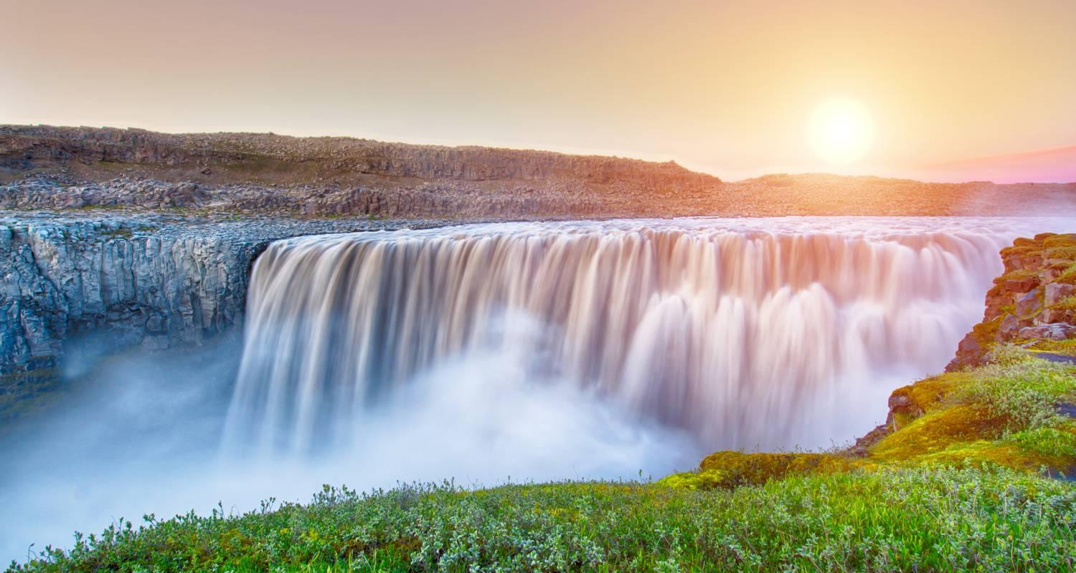



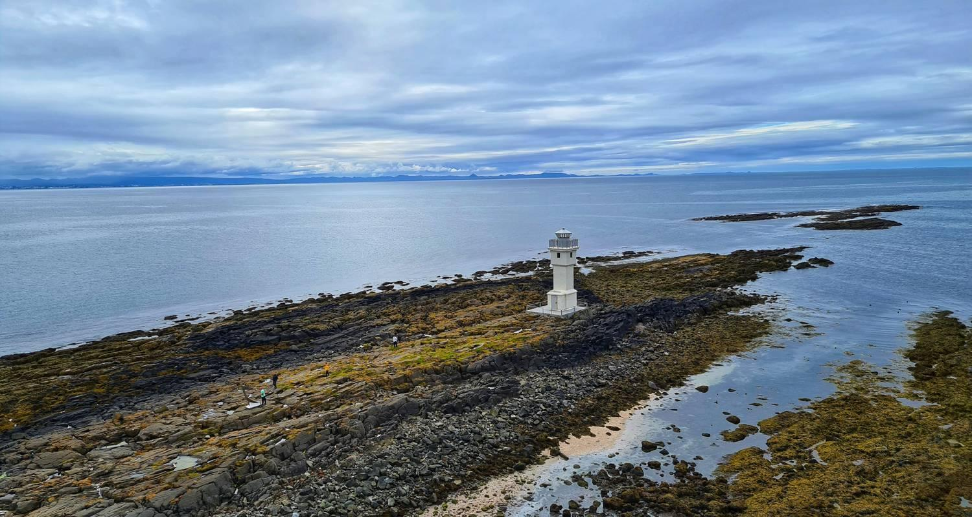

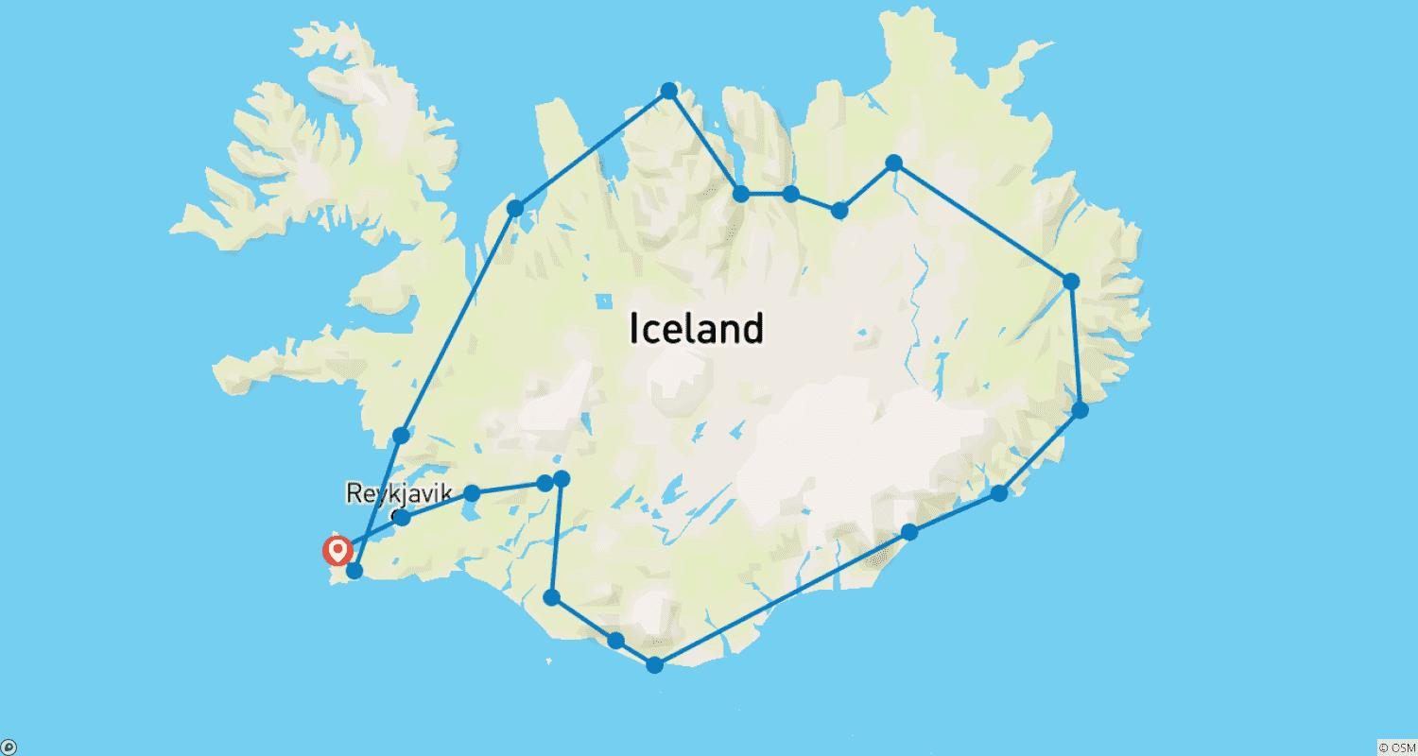

Tour ID: 216162  
Tour Name: Icelandic Adventure (2023)

Tour destinations: ['Reykjavik', 'Myvatn', 'Husavik', 'Akureyri', 'Borgarnes', 'Blue Lagoon']

Tour destinations images:

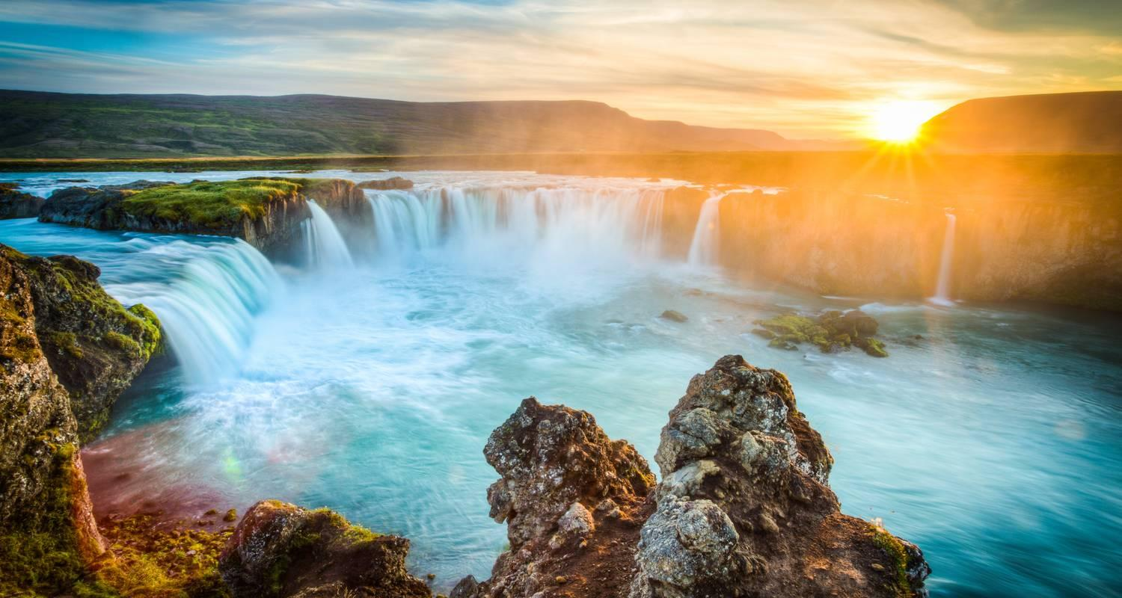

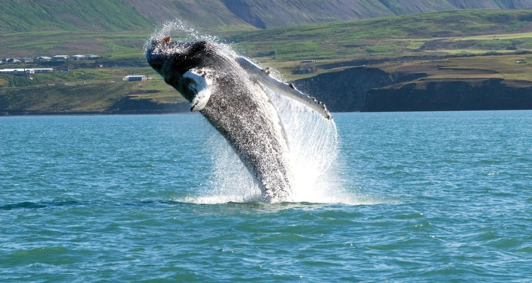

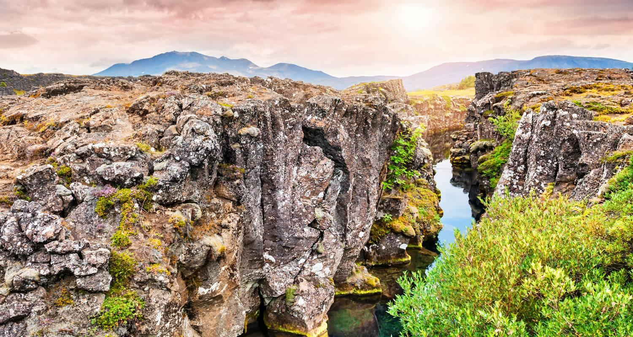

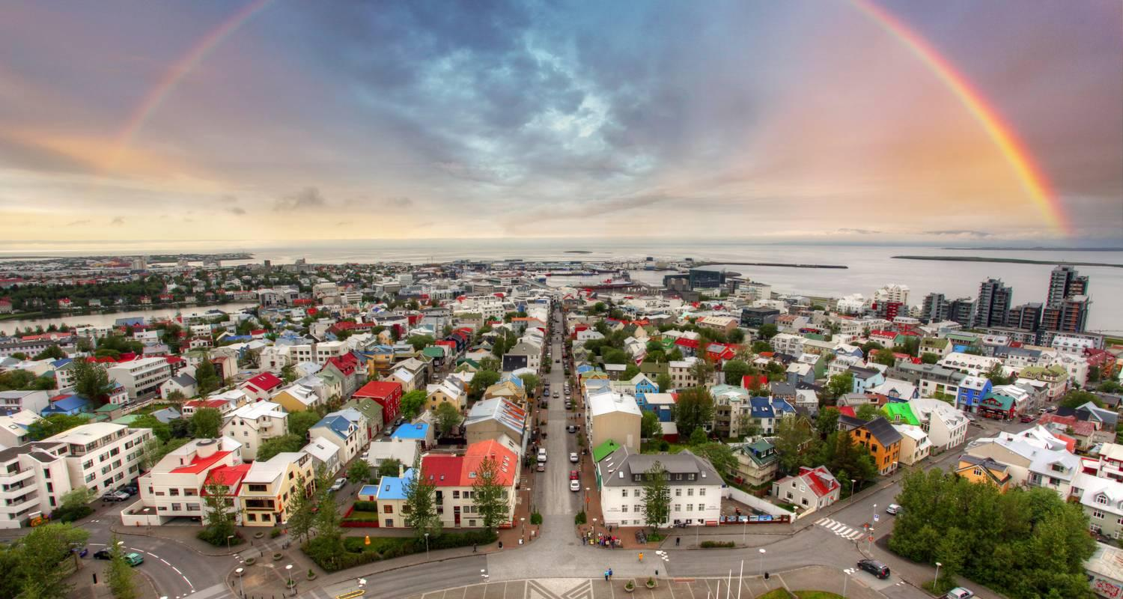

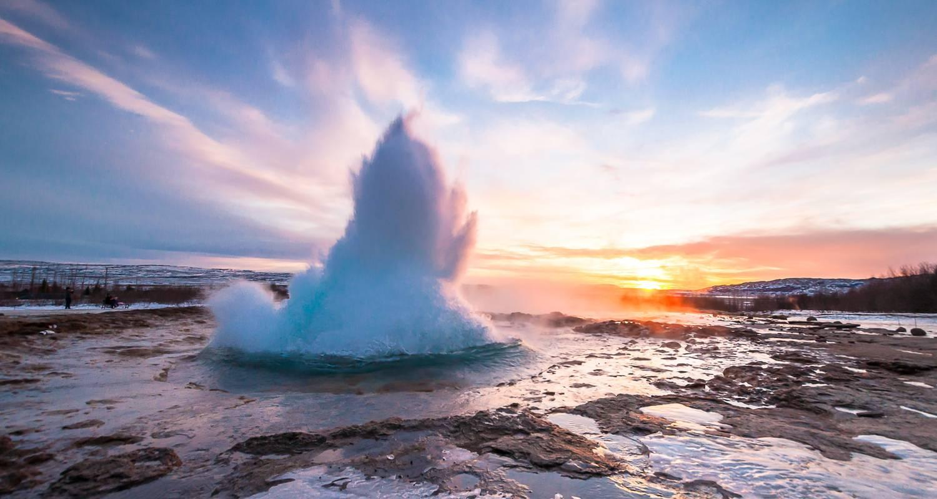

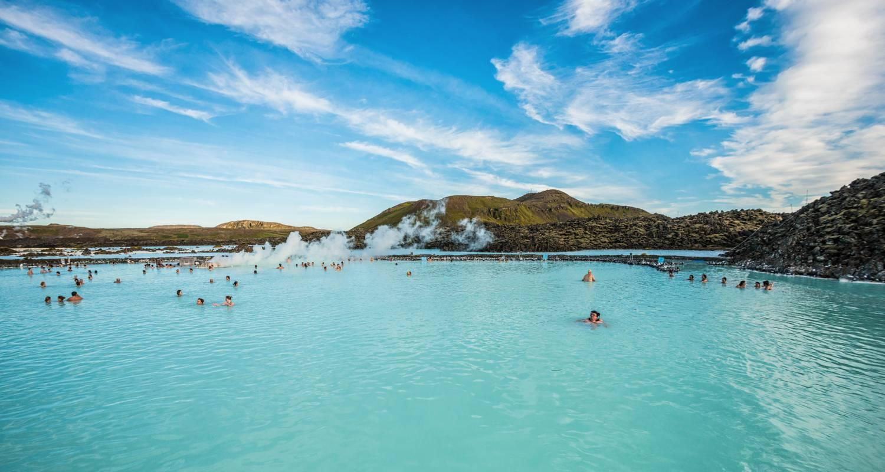

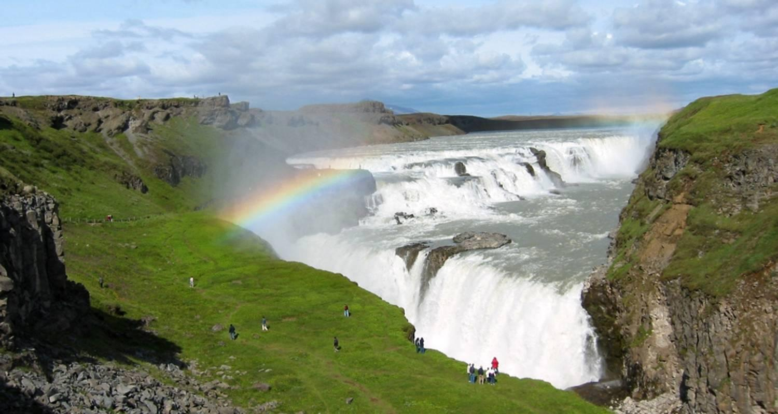

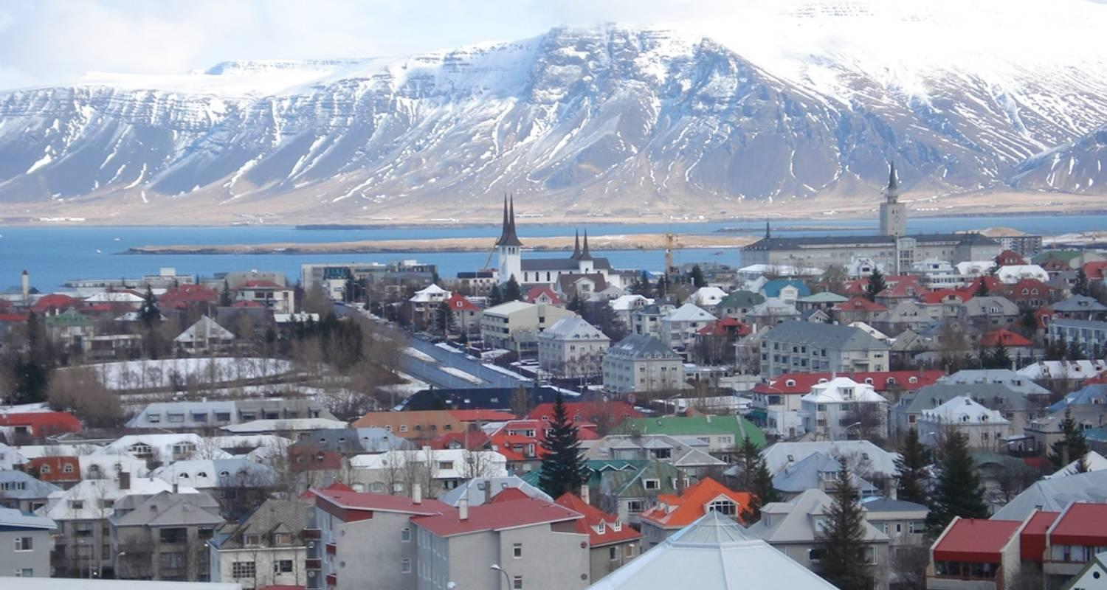

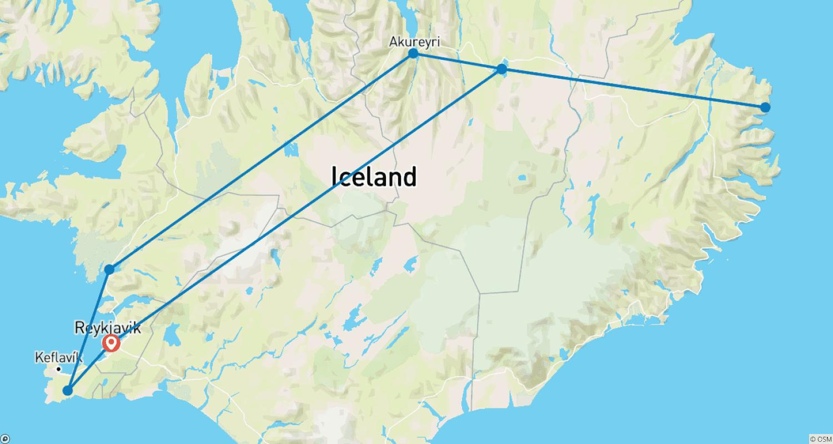

Tour ID: 216336  
Tour Name: 12 Days Self-drive | Everything your must see in Iceland Ring Road Tour

Tour destinations: ['Keflavik', 'Blue Lagoon', 'Borgarnes', 'Kirkjufell Mountain', 'Arnarstapi', 'Hraunfossar', 'Hvitserkur', 'Siglufjordur', 'Akureyri', 'Godafoss', 'Myvatn', 'Dettifoss', 'Egilsstadir', 'Djupivogur', 'Hofn', 'Jokulsarlon', 'Svartifoss', 'Reynisfjara', 'Skogafoss', 'Hvolsvollur', 'Gullfoss', 'Geysir', 'Thingvellir National Park', 'Reykjavik']

Tour destinations images:



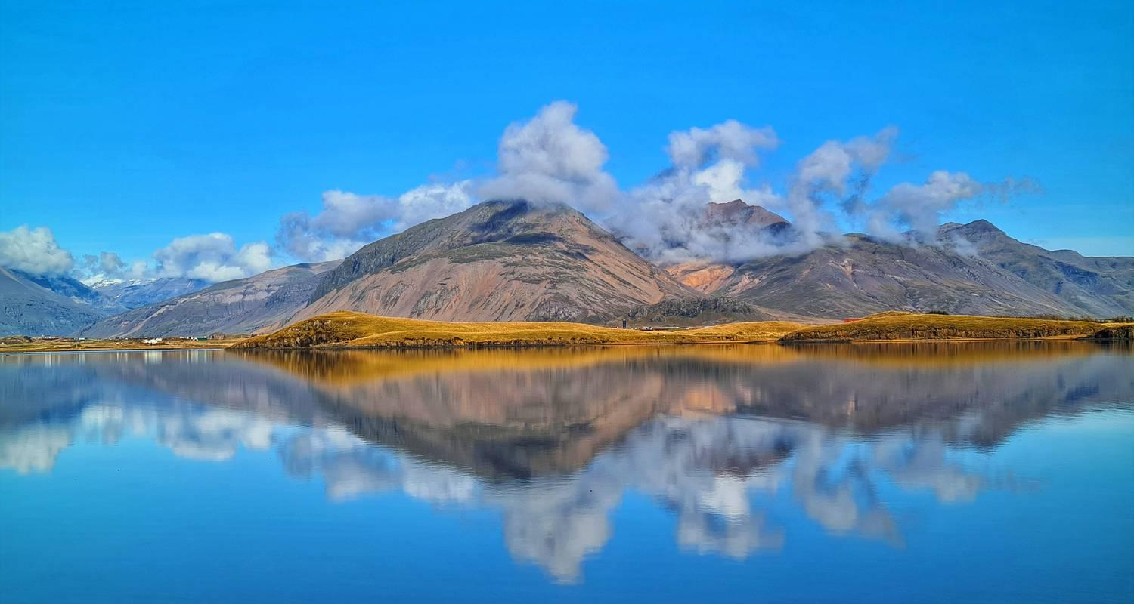



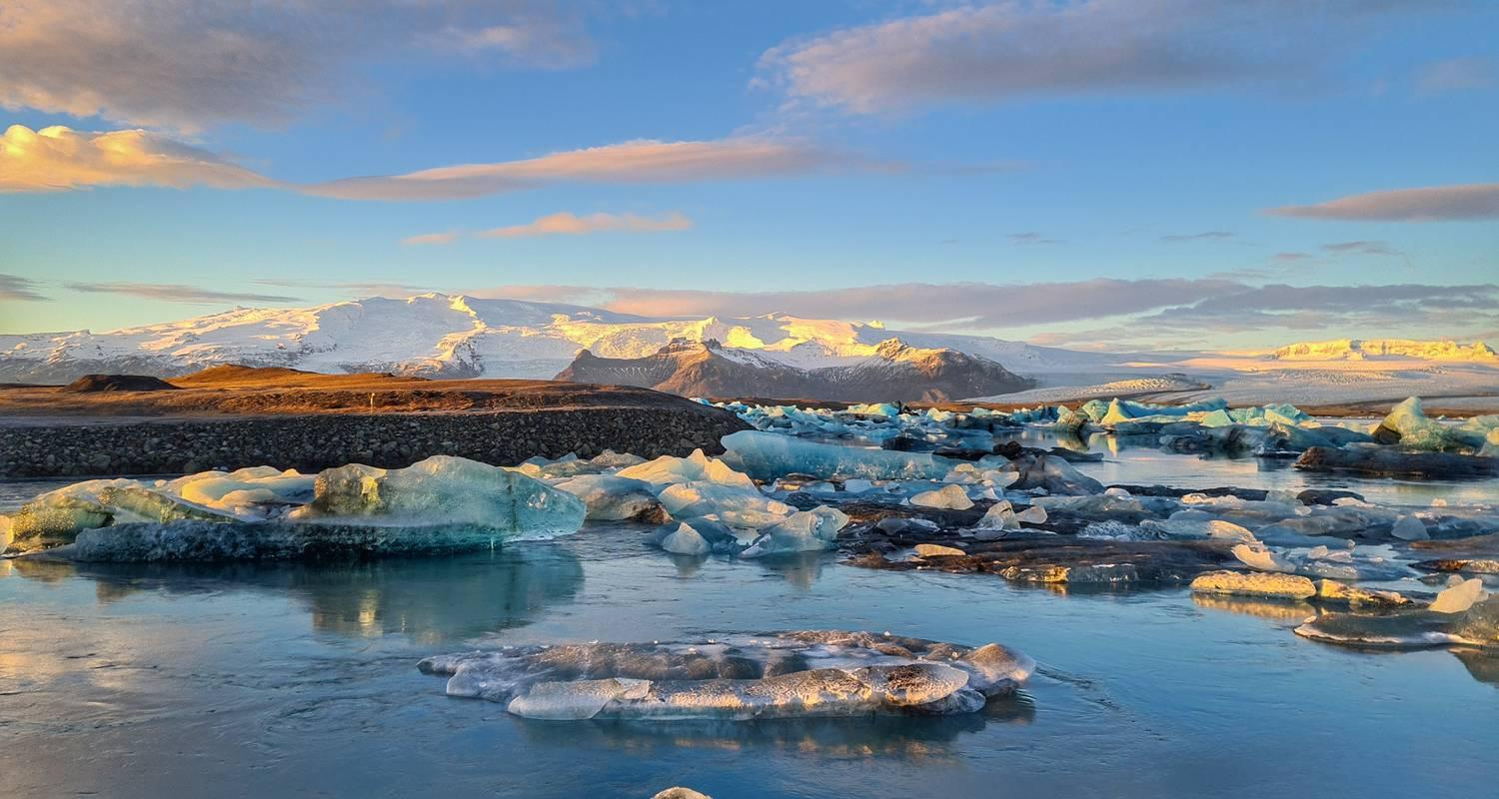

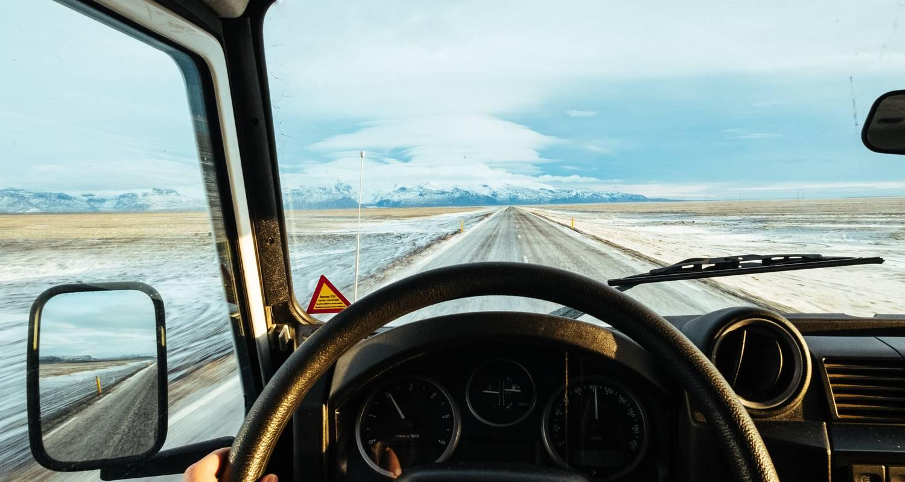

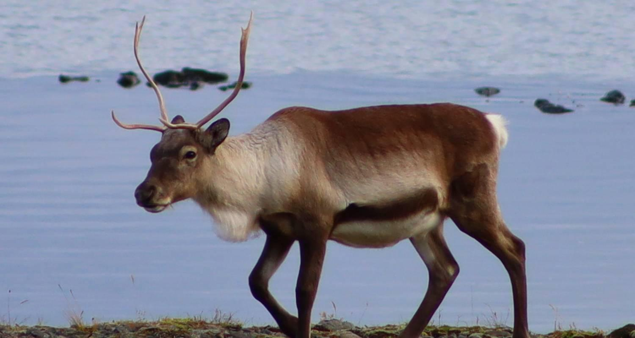







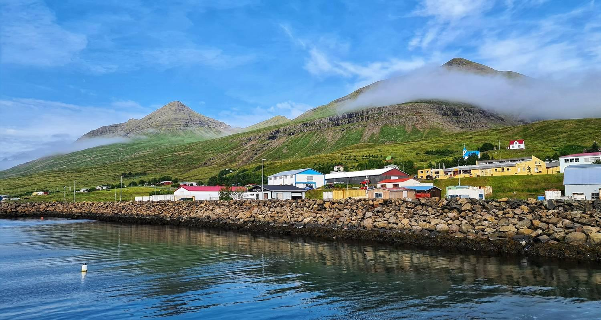

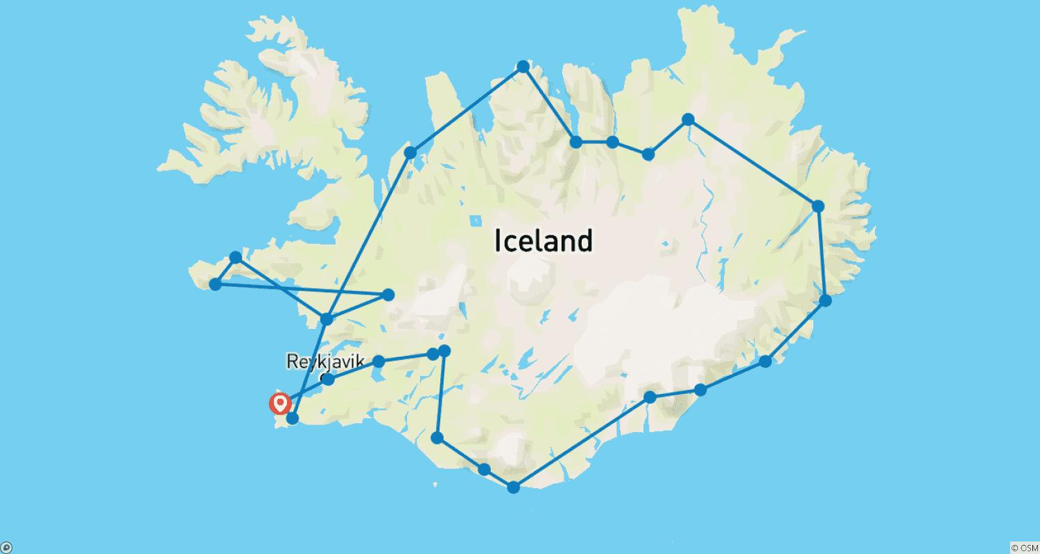

Tour ID: 217313  
Tour Name: 17 Days Self-drive | Complete Iceland Tour

Tour destinations: ['Keflavik', 'Reykholt', 'Hraunfossar', 'Borgarnes', 'Kirkjufell Mountain', 'Arnarstapi', 'Stykkisholmur', 'Patreksfjordur', 'Latrabjarg', 'Isafjordur', 'Holmavik', 'Hvitserkur', 'Siglufjordur', 'Akureyri', 'Godafoss', 'Myvatn', 'Dettifoss', 'Egilsstadir', 'Seydisfjordur', 'Djupivogur', 'Hofn', 'Jokulsarlon', 'Svartifoss', 'Reynisfjara', 'Skogafoss', 'Hvolsvollur', 'Gullfoss', 'Geysir', 'Thingvellir National Park', 'Reykjavik', 'Blue Lagoon']

Tour destinations images:







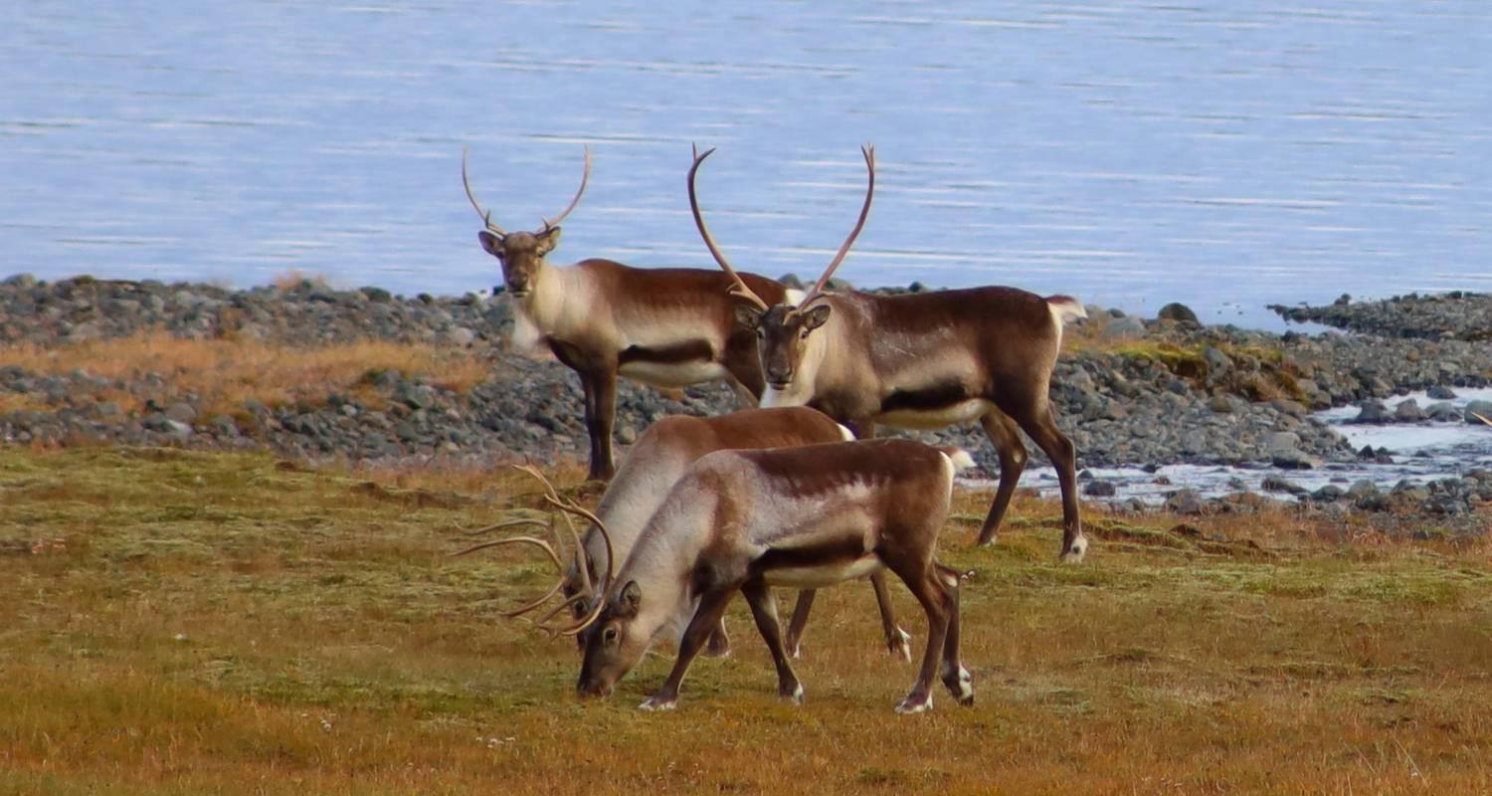







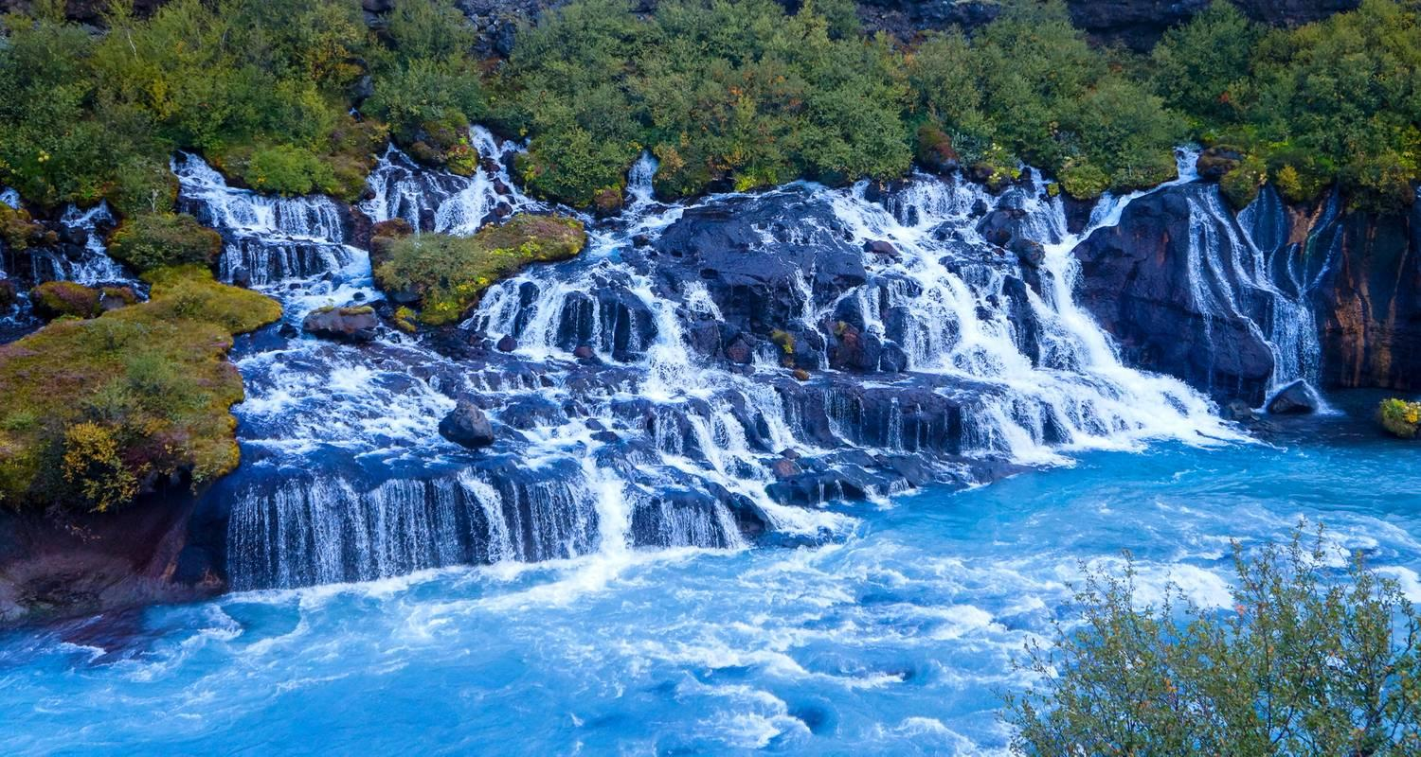

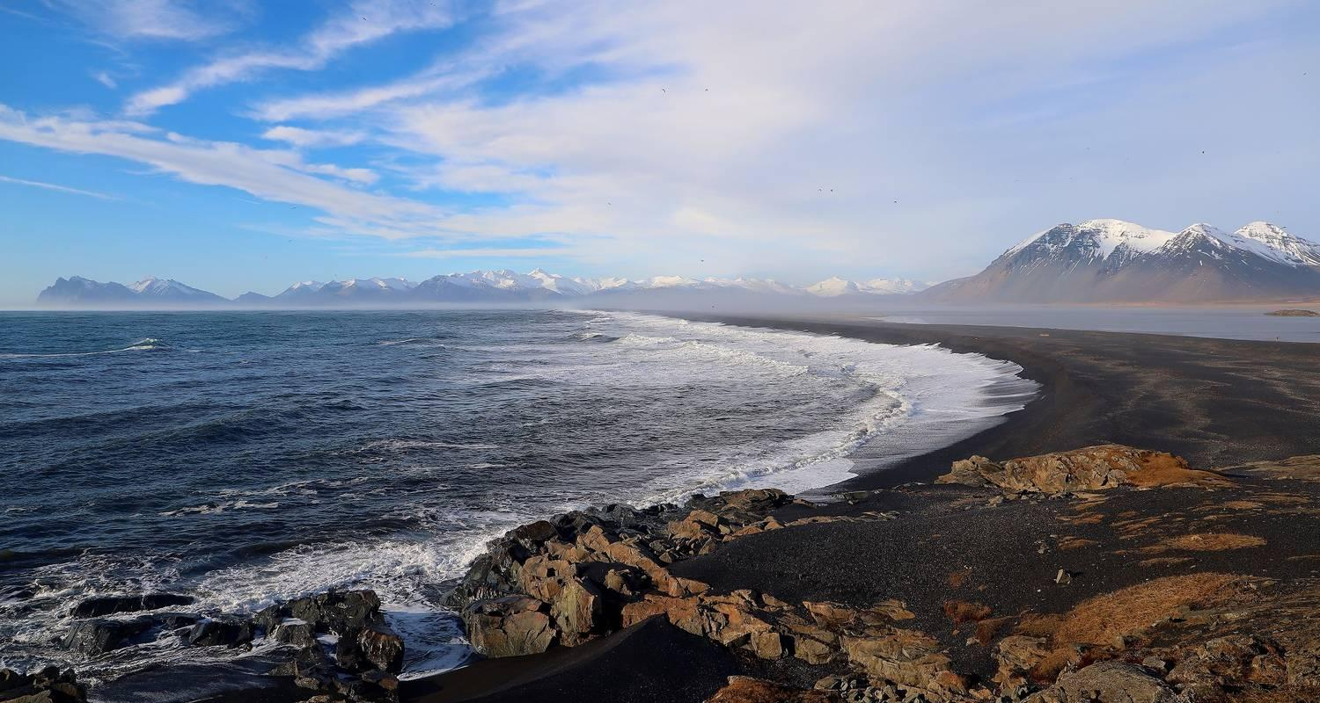



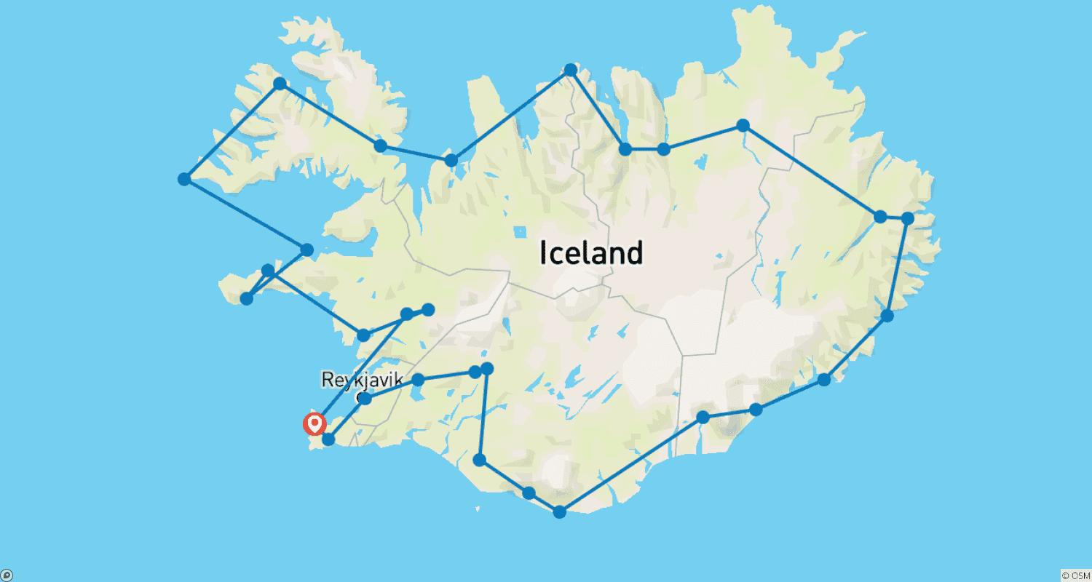

Tour ID: 217320  
Tour Name: 10 Days Self-drive | In-Depth Iceland Ring Road Tour

Tour destinations: ['Keflavik', 'Reykholt', 'Hraunfossar', 'Borgarnes', 'Kirkjufell Mountain', 'Arnarstapi', 'Hvitserkur', 'Siglufjordur', 'Akureyri', 'Godafoss', 'Myvatn', 'Dettifoss', 'Egilsstadir', 'Seydisfjordur', 'Djupivogur', 'Hofn', 'Jokulsarlon', 'Reynisfjara', 'Skogafoss', 'Hvolsvollur', 'Gullfoss', 'Geysir', 'Thingvellir National Park', 'Reykjavik', 'Blue Lagoon']

Tour destinations images:



















